Machine Learning Algorithms

# Regression

## Simple Linear Regression

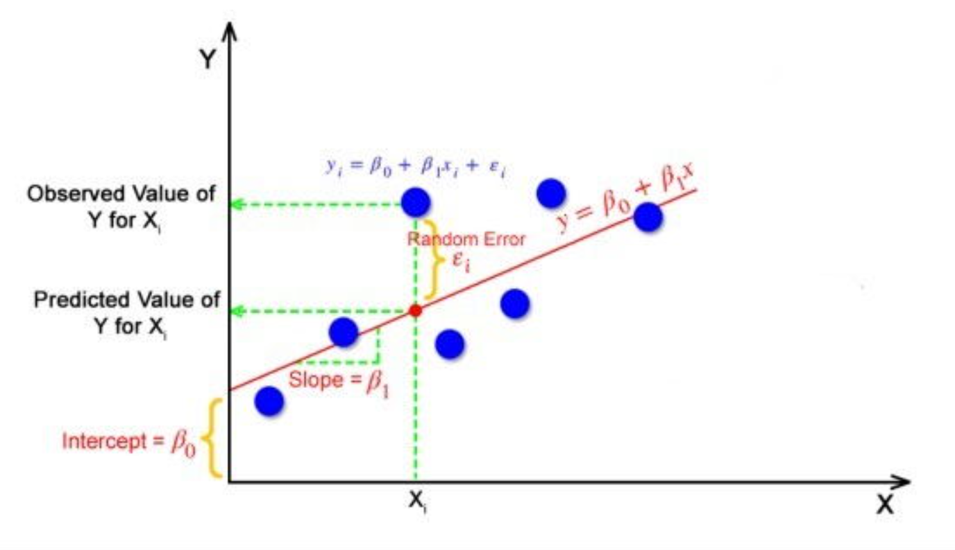

Linear Regression is to find the best fitting line for all the training data points.

The equation of a simple linear regression model is typically represented as:

Y = β0 + β1 * X + ε

Where:

* Y is the dependent variable (the variable we want to predict).
* X is the independent variable (the variable we use to make predictions).
* β0 is the y-intercept, representing the value of Y when X is 0.
* β1 is the slope, indicating how much Y changes for a one-unit increase in X.
* ε is the error term, representing the discrepancy between the predicted and actual values of Y.

To build a simple linear regression model, the algorithm calculates the values of β0 and β1 that minimize the sum of squared errors (SSE) between the predicted Y values and the actual Y values from the data. In other words, it finds the line that best fits the data points.

Once the model is built, it can be used to make predictions for the dependent variable Y based on new values of the independent variable X. Additionally, the model's goodness of fit can be assessed using various metrics, such as the coefficient of determination (R-squared), which measures the proportion of the variance in the dependent variable that is predictable from the independent variable.

### SSE

SSE stands for "Sum of Squared Errors." It is a metric that quantifies the difference between the predicted values of the dependent variable (Y) and the actual observed values in the data set.

Mathematically, SSE is calculated as the sum of the squared differences between the predicted Y values (Ŷi) and the actual Y values (Yi) for each data point i:

SSE = Σ(Yi - Ŷi)^2

Where:

* Yi represents the actual observed value of the dependent variable for data point i.
* Ŷi represents the predicted value of the dependent variable for data point i, calculated using the regression equation.
* Σ denotes the summation sign, indicating that you need to sum the squared differences for all data points in the data set.

The goal of linear regression is to find the line (represented by the regression equation) that minimizes SSE. In other words, the line that provides the best fit to the data and results in the smallest sum of squared errors is considered the best-fitting regression line.

## Multiple Linear Regression

Multiple linear regression is an extension of simple linear regression that allows for the modeling of the relationship between a dependent variable (response variable) and two or more independent variables (predictor variables). It is a powerful statistical technique used for prediction, understanding variable relationships, and making inferences about the impact of multiple factors on the outcome of interest.

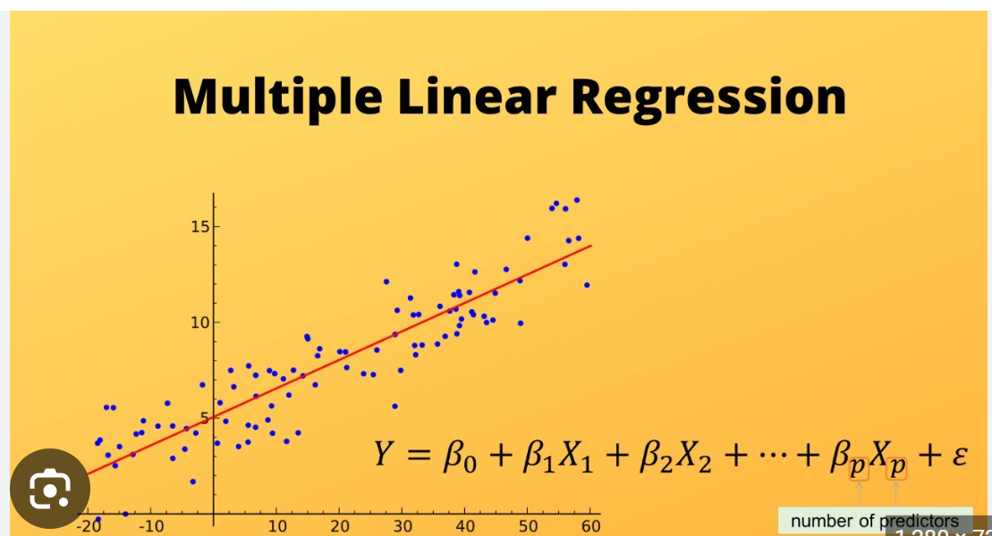

The equation for multiple linear regression is given as:

Y = β0 + β1 * X1 + β2 * X2 + ... + βn * Xn + ε

Where:

* Y is the dependent variable (the variable we want to predict).
* X1, X2, ..., Xn are the independent variables (the variables used to make predictions).
* β0 is the y-intercept, representing the value of Y when all independent variables are zero.
* β1, β2, ..., βn are the slopes or regression coefficients, indicating how much Y changes for a one-unit increase in each corresponding independent variable while holding other variables constant.
* ε is the error term, representing the discrepancy between the predicted and actual values of Y.

Similar to simple linear regression, the multiple linear regression model aims to find the best-fitting line that minimizes the sum of squared errors (SSE) between the predicted Y values and the actual Y values from the data. The regression coefficients (β1, β2, ..., βn) are estimated through statistical techniques like the method of least squares.

Multiple linear regression is particularly useful when there are several independent variables that may influence the dependent variable simultaneously. It allows us to understand how each independent variable contributes to the variability of the dependent variable while accounting for the effects of other variables in the model.

## Linear Regression Assumptions

Linear regression makes several key assumptions to ensure its validity and reliability. These assumptions are crucial for the interpretation of the model's results and to make meaningful predictions. Here are the main assumptions of linear regression:

1. Linearity: The relationship between the dependent variable (Y) and the independent variable(s) (X) is assumed to be linear. This means that the change in Y is directly proportional to the change in X. If the relationship is not linear, linear regression may not be appropriate, and other regression techniques should be considered.

Fix: Perform log or exponential transformation. Or use non linear regression

1. Independence: The observations in the dataset are assumed to be independent of each other. In other words, the value of one data point should not be influenced by or dependent on the value of another data point. Independence is crucial to avoid bias and ensure the reliability of estimates.
2. Homoscedasticity: Homoscedasticity, or constant variance, assumes that the residuals (the differences between the observed Y and the predicted Y) have a constant variance across all levels of the independent variables. In simpler terms, the spread of the residuals should remain consistent throughout the range of X. If the variance of the residuals changes with X, it indicates heteroscedasticity, which can affect the model's accuracy.

Fix:

* Look For Outlier bias/outliers
* Log transformations
* No autocorrelation between independent variables(Check for Durbin Watson value)

1. Normality: The residuals(error) of the model should follow a normal distribution. In a correctly specified linear regression model, the residuals should have a bell-shaped, symmetrical distribution around zero. Departure from normality can lead to biased estimates and incorrect hypothesis testing.
2. No multicollinearity: Multicollinearity refers to a situation where two or more independent variables are highly correlated. It can create problems in the model because it becomes challenging to distinguish the individual effects of the correlated variables on the dependent variable. High multicollinearity may lead to unstable coefficient estimates.
3. No endogeneity: Endogeneity occurs when the independent variables are correlated with the error term in the model. This can happen when there are omitted variables or simultaneous causation. Endogeneity violates the assumption that the independent variables are exogenous and can lead to biased coefficient estimates.

Fix: Always check for source of data and any factors missing

1. Large sample size: Linear regression works best with a reasonably large sample size to ensure reliable parameter estimates and statistical inferences. A small sample size may lead to less precise estimates and less reliable results.

## Polynomial Linear Regression

Polynomial linear regression is a variant of linear regression in which the relationship between the independent variable(s) and the dependent variable is modeled as an nth-degree polynomial. While simple linear regression assumes a straight-line relationship between the variables, polynomial regression allows for more complex and nonlinear relationships.

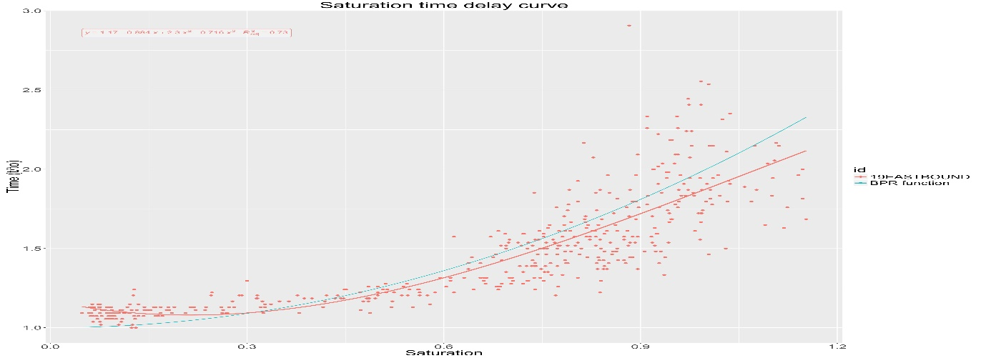

The general equation for polynomial linear regression can be expressed as follows:

Y = β₀ + β₁*X + β₂*X² + β₃*X³ + ... + βₙ*Xⁿ + ε

where:

* Y is the dependent variable (the target variable you want to predict).
* X is the independent variable (the predictor variable).
* β₀, β₁, β₂, ..., βₙ are the coefficients that represent the relationship between each power of X and Y.
* ε is the error term, representing the residual or unexplained variation.

In this model, you can adjust the degree (n) of the polynomial to create a best-fitting curve through the data points. For instance, for n=2, you have a quadratic regression, and for n=3, you have a cubic regression.

Here are the general steps to perform polynomial linear regression:

1. **Data Preparation**: Ensure your data is cleaned, and relevant variables are selected.
2. **Feature Transformation**: Transform your independent variable(s) X into a matrix containing polynomial terms up to the desired degree. For example, if you want a quadratic regression, you'd create new features X².
3. **Split Data**: Divide your dataset into training and testing sets to evaluate the model's performance.
4. **Model Fitting**: Use the training data to estimate the coefficients (β₀, β₁, β₂, ..., βₙ) that best fit the polynomial regression model.
5. **Model Evaluation**: Evaluate the model's performance on the test data using appropriate metrics like Mean Squared Error (MSE), R-squared, etc.
6. **Visualization**: Plot the data points along with the polynomial curve to visualize the model's fit.

It's important to note that higher-degree polynomials might overfit the data, capturing noise instead of the underlying pattern. Therefore, it's essential to choose the appropriate degree for the polynomial based on the data and consider techniques like cross-validation to assess model performance and avoid overfitting.

## Support Vector Regression

Support Vector Regression (SVR) is a supervised machine learning algorithm used for regression tasks. It is an extension of Support Vector Machines (SVM) that are typically used for classification. SVR is particularly useful when dealing with nonlinear relationships between the input features and the target variable.

In SVR, the main idea is to find a hyperplane (or multiple hyperplanes in the case of non-linear kernels) that best fits the data while controlling the margin and limiting the error between the predicted and actual target values. The hyperplane is defined by a set of support vectors, which are data points that lie closest to the hyperplane.

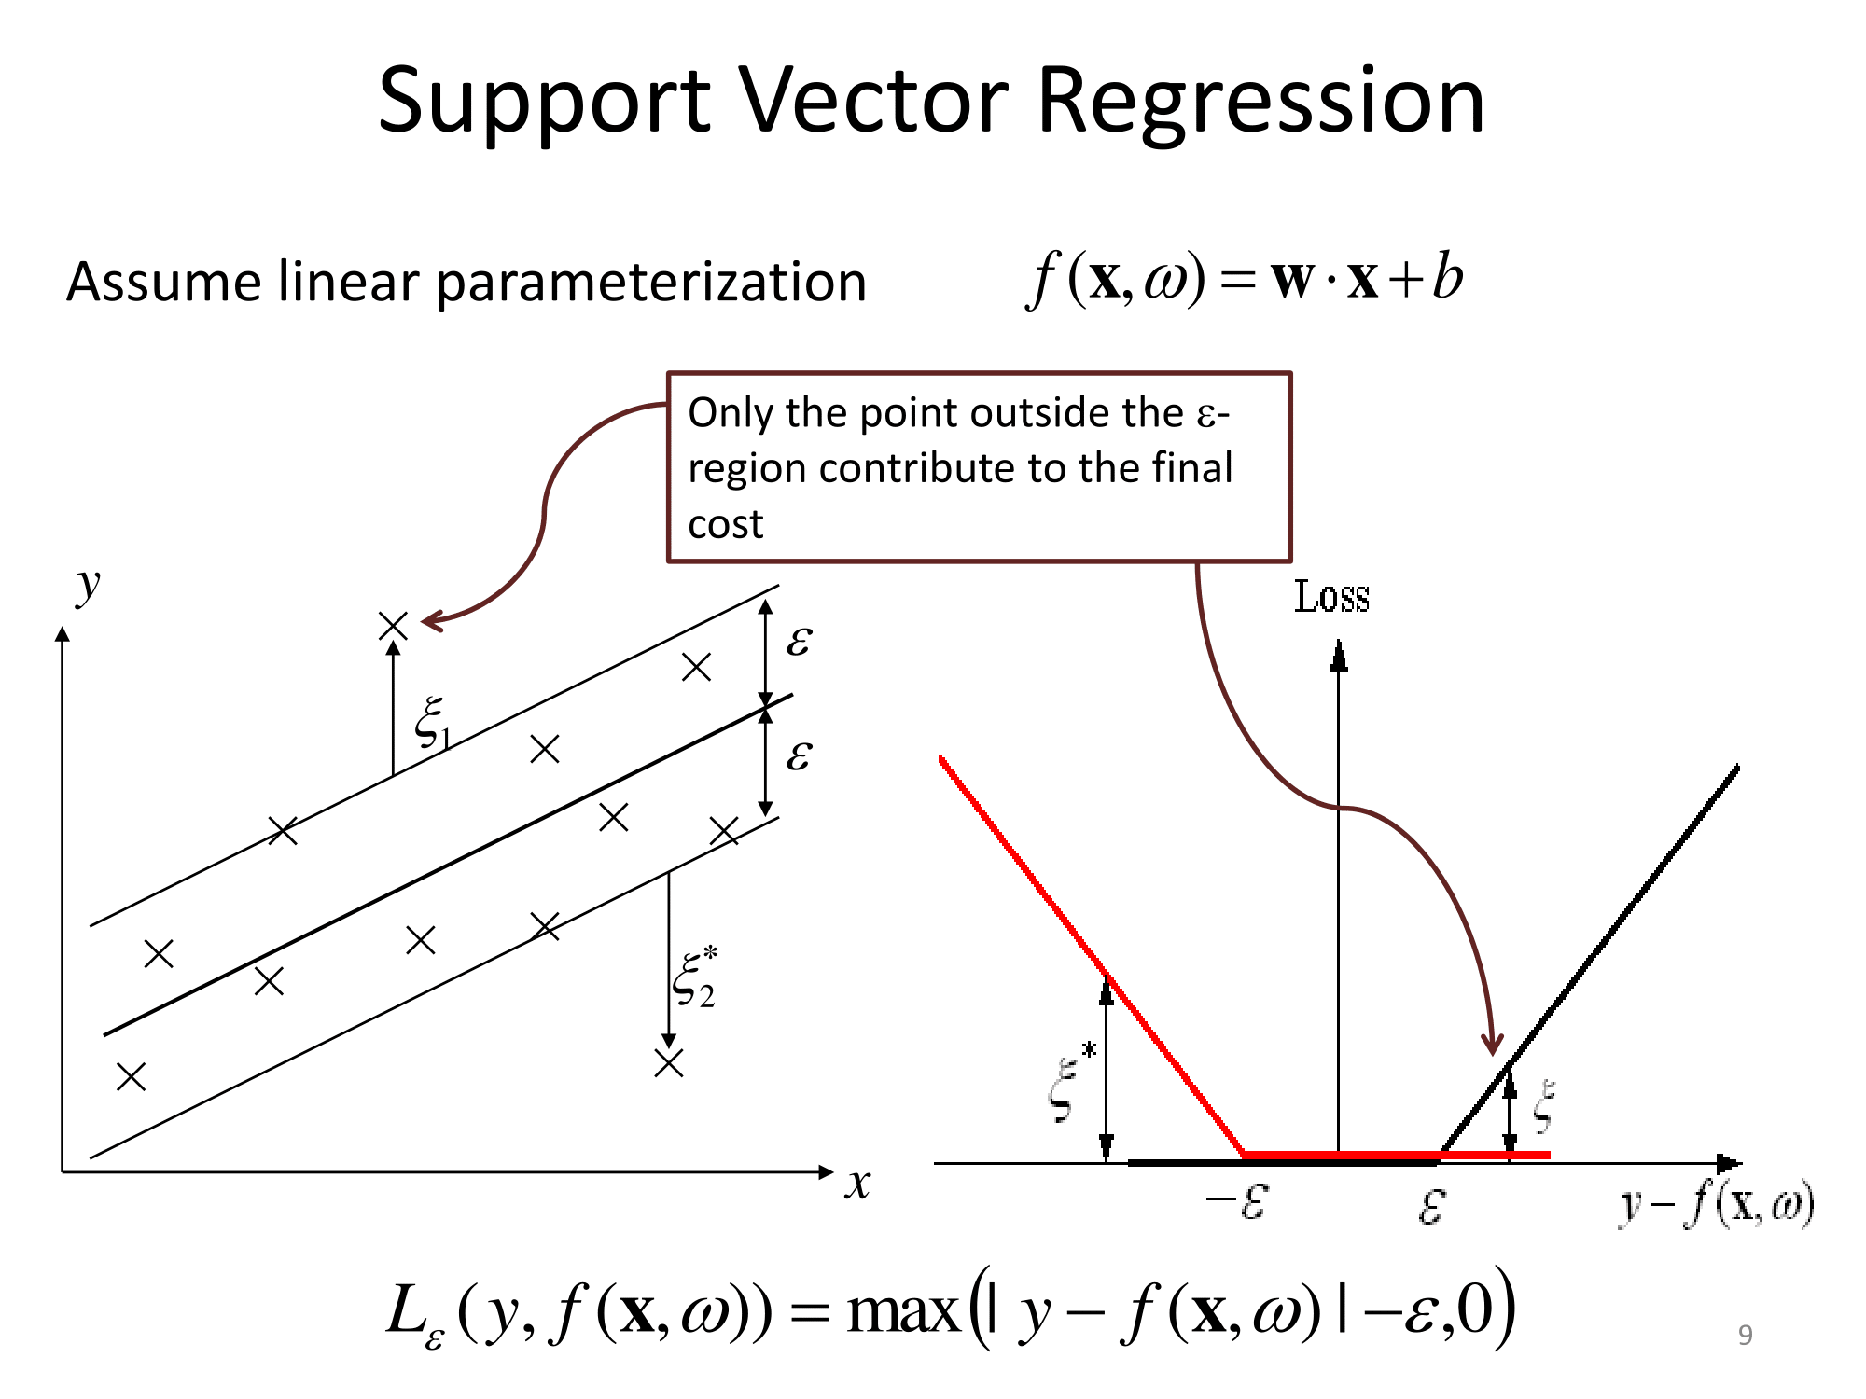

Any points inside the ε tube(region) in the image( left ) don’t contribute to the error. This is called the insensitive tube.

The general formulation of the SVR objective is to minimize the following cost function:

minimize: (1/2) * ||w||^2 + C * Σ(max(0, |yi - f(xi)| - ε))

subject to: w * xi - b <= ε and b - w * xi <= ε for all data points (xi, yi)

where:

* f(xi) is the predicted value for data point xi.
* ε is the margin or the acceptable error threshold.
* C is the regularization parameter, controlling the trade-off between maximizing the margin and minimizing the training error.
* w is the weight vector associated with the hyperplane.
* b is the bias term.

SVR can handle both linear and non-linear relationships between the features and the target variable through the use of different kernels. Commonly used kernels include Linear, Polynomial, Radial Basis Function (RBF), and Sigmoid kernels.

The key steps in using SVR are as follows:

1. **Data Preparation**: Clean and preprocess your data, ensuring that you have appropriate features and a target variable for regression.
2. **Feature Scaling**: Scaling the features is essential for SVR since it is sensitive to the scale of the input variables. Common scaling methods include Standardization (mean=0, std=1) or Min-Max scaling (scaling data to a specific range, e.g., [0, 1]).
3. **Selecting the Kernel**: Choose an appropriate kernel based on your data and the complexity of the relationship between the features and the target variable.
4. **Model Training**: Fit the SVR model to your training data with the chosen kernel and regularization parameter (C).
5. **Model Evaluation**: Assess the performance of the SVR model using evaluation metrics such as Mean Squared Error (MSE), R-squared, or other relevant regression metrics.
6. **Model Tuning**: Depending on the performance, you may need to adjust hyperparameters like C, ε, or kernel parameters to improve the model's performance and generalization.

## Decision Tree Regression

Decision tree regression is a non-parametric supervised machine learning algorithm used for regression tasks. Unlike linear regression, decision tree regression is capable of capturing non-linear relationships between the features and the target variable. It works by recursively splitting the data into subsets based on the most significant feature(s) to create a tree-like structure that can be used for predictions.

The decision tree regression algorithm works as follows:

1. **Data Preparation**: Clean and preprocess your data, ensuring that you have appropriate features and a target variable for regression.
2. **Building the Tree**: The algorithm starts by selecting the feature and threshold that best splits the data into subsets to minimize the sum of squared errors (or another appropriate splitting criterion). The data is then split into two subsets based on this feature and threshold.
3. **Recursive Splitting**: The process of splitting is repeated on each subset independently. The algorithm selects the best feature and threshold for each subset and further divides it into smaller subsets. This process continues until a stopping criterion is met, such as a maximum tree depth or a minimum number of samples per leaf.
4. **Prediction**: To make predictions for new data points, the algorithm follows the decision path down the tree from the root node to a leaf node. The predicted value for the new data point is the average (or weighted average) of the target values in the corresponding leaf node.

Decision tree regression has several advantages:

* Easy to interpret and visualize: The resulting tree structure is easy to understand and interpret, making it useful for explaining the decision-making process.
* Nonlinear relationships: Decision trees can capture non-linear relationships in the data, making them suitable for a wide range of regression tasks.
* Robust to outliers: Decision trees are less affected by outliers compared to some other regression algorithms.

However, decision tree regression also has some limitations:

* Overfitting: Decision trees can easily overfit the training data, especially if the tree is deep or the number of samples per leaf is small. Regularization techniques like pruning or using a maximum tree depth can help mitigate overfitting.
* Instability: Small changes in the data can lead to different tree structures, making the model less stable.
* Extrapolation: Decision trees do not handle extrapolation well, and predictions outside the range of the training data might not be reliable.

## Random Forest Regression

Random Forest Regression is an ensemble machine learning technique that combines the power of multiple decision trees to perform regression tasks. It is an extension of the decision tree algorithm, addressing some of its limitations, such as overfitting and instability, while maintaining the ability to capture complex relationships in the data.

The main idea behind Random Forest Regression is to build a multitude of decision trees on random subsets of the data and average their predictions to make the final prediction. Each tree is trained on a different bootstrap sample of the data (randomly sampled with replacement), and at each split, only a random subset of the features is considered. This introduces randomness and diversity into the model, making it less prone to overfitting and improving its generalization capabilities.

Here are the key steps involved in Random Forest Regression:

1. **Data Preparation**: Clean and preprocess your data, ensuring that you have appropriate features and a target variable for regression.
2. **Building the Random Forest**: The algorithm creates a specified number of decision trees (n_estimators) using random subsets of the data and features. Each tree is trained independently on a bootstrap sample.
3. **Feature Randomness**: At each node of each decision tree, only a random subset of features is considered for the best split, which introduces additional randomness into the model.
4. **Prediction**: To make predictions for new data points, the algorithm averages the predictions from all the individual decision trees in the forest.

Random Forest Regression offers several benefits:

* Robustness: Random Forest is less sensitive to outliers and noise in the data compared to a single decision tree.
* Generalization: The ensemble of trees improves generalization, reducing the risk of overfitting on the training data.
* Feature Importance: Random Forest can provide information about feature importance, indicating which features have the most significant impact on the target variable.
* Versatility: Random Forest can handle both numerical and categorical features without the need for extensive data preprocessing.

However, it's essential to be aware of the potential trade-offs:

* Complexity: Random Forest is computationally more intensive than a single decision tree, especially for large datasets or a high number of estimators.
* Interpretability: While Random Forest can provide feature importance, the overall model interpretability might be more challenging compared to a single decision tree.

Random Forest Regression is widely used for various regression tasks, especially when the dataset contains complex relationships and a large number of features. It is implemented in popular machine learning libraries such as scikit-learn (Python) and randomForest (R). To improve performance and tune hyperparameters, you can use techniques like cross-validation and grid search.

## Evaluating Regression Models

Here's a explanation of the regression model evaluation techniques along with their formulae:

1. **Mean Squared Error (MSE)**: MSE = (1/n) * Σ(yᵢ - ȳ)²

Where:

* n is the number of data points.
* yᵢ is the actual target value for the ith data point.
* ȳ is the mean of the actual target values.

MSE calculates the average squared difference between the predicted values and the actual target values. It penalizes larger errors more heavily, making it a widely used metric for regression evaluation.

1. **Root Mean Squared Error (RMSE)**: RMSE = √MSE

RMSE is the square root of MSE and provides an error measure in the same units as the target variable. It is easier to interpret compared to MSE and is commonly used for regression model evaluation.

1. **Mean Absolute Error (MAE)**: MAE = (1/n) * Σ|yᵢ - ȳ|

MAE calculates the average absolute difference between the predicted values and the actual target values. It is less sensitive to outliers compared to MSE and provides a more robust evaluation metric.

1. **R-squared (R²)**: R² = 1 - (SSR/SST)

Where:

* SSR (Sum of Squares Regression) = Σ(yᵢ - ȳ)² (explained variation by the model)
* SST (Sum of Squares Total) = Σ(yᵢ - ȳ)² (total variation in the data)

R-squared measures the proportion of variance in the target variable that is explained by the model. It ranges from 0 to 1, with higher values indicating a better fit. However, be cautious when using R-squared for models with a large number of predictors.

1. **Adjusted R-squared**: Adjusted R² = 1 - [(1-R²) * (n-1) / (n-p-1)]

Where:

* p is the number of predictors (independent variables) in the model.

Adjusted R-squared adjusts the R-squared value for the number of predictors in the model. It penalizes excessive complexity and provides a better representation of the model's goodness of fit, especially in models with many predictors.

## Selecting Variables for Regression

Building a model involves several steps, including data preprocessing, selecting variables, model training, and evaluation. how you can approach the process of variable selection using three methods: All-In, Backward Elimination, and Forward and Bidirectional Elimination. These are iterative methods used in multiple linear regression. For other types of models, different variable selection techniques might be more appropriate.

Assume you have a dataset with a target variable (Y) and several potential predictor variables (X1, X2, ..., Xn).

1. **All-In Method**:

* Include all predictor variables (X1, X2, ..., Xn) in the model.
* Train the model using multiple linear regression.
* Evaluate the model's performance using appropriate metrics (e.g., R-squared, Mean Squared Error).
* If the model performs well and meets your requirements, you can consider this your final model.
* If the model does not meet your performance criteria or you want to simplify it, proceed to the next methods.

1. **Backward Elimination Method**:

* Start with all predictor variables (X1, X2, ..., Xn) in the model.
* Train the model using multiple linear regression.
* Evaluate the performance of the model.
* Remove the predictor variable with the highest p-value (least significant) from the model.
* Re-train the model without the removed variable.
* Continue this process iteratively, removing the least significant variable at each step, until all remaining variables have acceptable p-values.
* Evaluate the final model and ensure it meets your performance criteria.

1. **Forward and Bidirectional Elimination Method**:

* Forward Elimination:
  + Start with an empty model (no predictor variables).
  + Train the model with each predictor variable separately and choose the one that gives the best performance (e.g., highest R-squared or lowest Mean Squared Error).
  + Add this chosen variable to the model.
  + Iterate by adding one predictor variable at a time until no more variables can significantly improve the model's performance.
* Bidirectional Elimination:
  + Start with all predictor variables included in the model.
  + Perform backward elimination on the current model (as described in method 2) to remove the least significant variable.
  + Then, perform forward elimination on the reduced model to add any new significant predictor variables that were previously excluded.
  + Continue this process iteratively until no more variables can be added or removed to significantly improve the model's performance.

1. **Evaluation**:

* Once you have your final model, evaluate it on a separate validation dataset to ensure its generalization ability.
* Use appropriate evaluation metrics to assess the model's performance and make any necessary adjustments or refinements.

Note: Scikit is intelligent. It mostly handls variable selection and dummy variables as well. No need to manually do it.

# Classification

## Logistic Regression

Hello! Logistic regression is a popular statistical method used for binary classification tasks. It is widely used in machine learning and statistics for predicting a binary outcome (i.e., a Yes/No or True/False outcome) based on one or more predictor variables.

In logistic regression, the model predicts the probability of the binary outcome occurring given the input features. The output of the logistic regression model is a value between 0 and 1, representing the probability of the positive class (e.g., "Yes" or "True"). To convert this probability into a binary prediction, a threshold is applied (usually 0.5). If the predicted probability is above the threshold, the positive class is predicted; otherwise, the negative class is predicted.

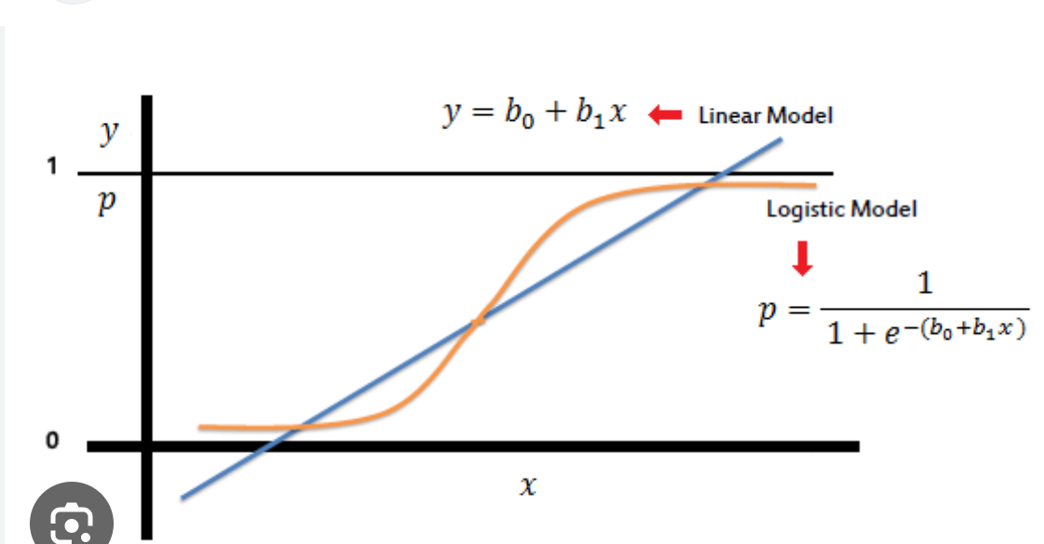

The logistic regression model uses the logistic function (sigmoid function) to map the output to a probability. The formula for the logistic regression model can be represented as:

P(y=1 | X) = 1 / (1 + e^(-Z))

Where:

* P(y=1 | X) is the probability of the positive class given the input features X.
* Z is the linear combination of the input features and their corresponding coefficients.

The logistic regression model estimates the coefficients for the input features during the training process. The coefficients determine the influence of each feature on the predicted probability. The model is trained by minimizing a loss function, often the log-loss or cross-entropy loss, using optimization techniques like gradient descent.

Logistic regression is a linear model, meaning it assumes a linear relationship between the input features and the log-odds of the binary outcome. If the relationship between the features and the log-odds is more complex, other models like support vector machines (SVM) or neural networks may be more appropriate.

## K Nearest Neighbors

K-Nearest Neighbors (KNN) is a popular and simple supervised machine learning algorithm used for classification and regression tasks. It is a non-parametric and lazy learning algorithm, meaning it doesn't make any assumptions about the underlying data distribution and it postpones generalization until prediction time.

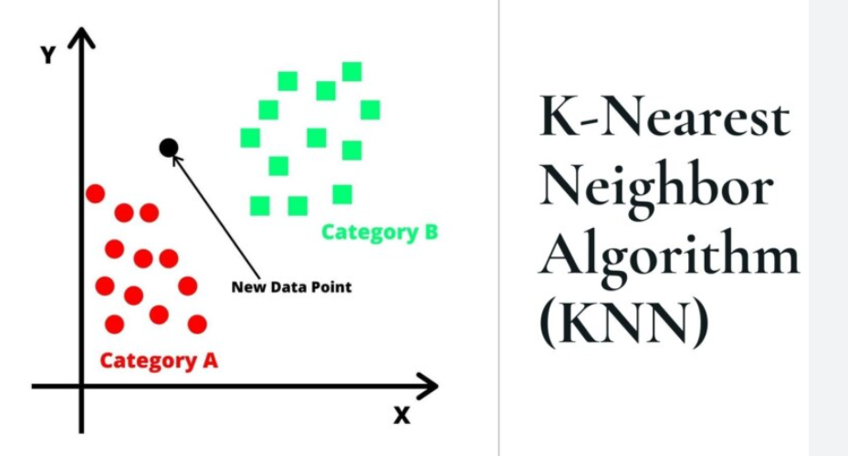

In KNN, the "K" represents the number of nearest neighbors that are considered for making a prediction. Here's how the KNN algorithm works for classification:

1. Training Phase:

* The algorithm memorizes the entire training dataset, which consists of labeled data points (feature vectors) and their corresponding class labels.

1. Prediction Phase:

* When a new data point (unlabeled) is given as input, the algorithm finds the "K" nearest neighbors to this data point in the training dataset.
* It does this by measuring the distance (usually Euclidean distance) between the new data point and all the points in the training dataset.
* The "K" nearest neighbors are the data points with the smallest distances to the new data point.

1. Classification (for KNN classification):

* Once the "K" nearest neighbors are identified, the algorithm takes a majority vote among the class labels of these neighbors.
* The class label that appears most frequently among the neighbors is assigned as the predicted class label for the new data point.

For KNN regression, the prediction is the average of the "K" nearest neighbors' target values (i.e., the output variable for regression tasks).

The choice of "K" is an important hyperparameter in KNN. A small "K" can lead to noisy predictions, while a large "K" can cause oversmoothing of the decision boundaries. The optimal "K" value can be determined through cross-validation or other hyperparameter tuning techniques.

One advantage of KNN is that it can handle non-linear relationships between features and the target variable. However, it can be computationally expensive, especially for large datasets, as it requires calculating distances between the new data point and all training samples during the prediction phase.

KNN is a simple and intuitive algorithm, and it serves as a good baseline for many classification and regression tasks. However, in practice, other more sophisticated algorithms like decision trees, random forests, support vector machines, or neural networks are often used for better performance and efficiency in real-world scenarios.

## Support Vector Machine

Support Vector Machine (SVM) is a powerful and versatile supervised machine learning algorithm used for both classification and regression tasks. It is particularly well-suited for binary classification problems but can also be extended to handle multi-class classification.

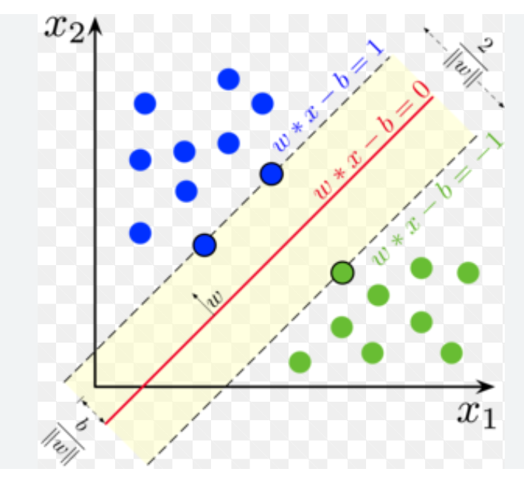

The key idea behind SVM is to find the optimal hyperplane that best separates the data points of different classes in a high-dimensional feature space. The "support vectors" are the data points closest to the decision boundary (hyperplane), which play a crucial role in defining the hyperplane. SVM aims to maximize the margin between the support vectors of different classes, making it a "maximal margin classifier."

Here's how SVM works for binary classification:

1. Training Phase:

* Given a labeled training dataset with feature vectors and their corresponding class labels, SVM finds the optimal hyperplane that separates the data points of different classes.
* The feature vectors are mapped into a higher-dimensional feature space using a "kernel" function. The kernel function helps SVM to handle non-linear decision boundaries efficiently.
* SVM tries to find the hyperplane that maximizes the margin between the support vectors of different classes while minimizing the classification error.

1. Prediction Phase:

* For a new, unlabeled data point, SVM maps it into the same higher-dimensional feature space using the same kernel function.
* Then, it predicts the class of the new data point based on which side of the decision boundary (hyperplane) it lies in the high-dimensional space.

SVM can handle complex decision boundaries and is less affected by the curse of dimensionality compared to some other algorithms. The choice of the kernel function (e.g., linear, polynomial, radial basis function - RBF, etc.) is important and depends on the characteristics of the data.

Some of the advantages of SVM include:

* Effective in high-dimensional spaces.
* Versatile due to various kernel functions.
* Good generalization performance.
* Works well with small to medium-sized datasets.

However, SVM can become computationally expensive and memory-intensive for large datasets. Also, tuning the hyperparameters, such as the regularization parameter and the kernel parameters, can be challenging.

For multi-class classification problems, SVM can be extended using techniques like One-vs-One (OvO) or One-vs-All (OvA) to handle multiple classes.

In addition to classification tasks, SVM can be adapted for regression tasks, known as Support Vector Regression (SVR), where it tries to fit the best possible hyperplane within a specified margin around the target values.

Overall, SVM is a powerful and widely used algorithm in the field of machine learning, and it has proven to be effective in many real-world applications.

### Kernel SVM

Kernel SVM, also known as Kernel Support Vector Machine, is an extension of the traditional Support Vector Machine (SVM) algorithm that allows handling non-linear decision boundaries efficiently. It achieves this by implicitly transforming the input data into a higher-dimensional feature space using a kernel function, without actually calculating the feature vectors explicitly.

The motivation behind Kernel SVM is to deal with datasets that are not linearly separable in their original feature space. Instead of manually mapping the data into a higher-dimensional space, which can be computationally expensive, Kernel SVM uses a kernel function to compute the dot products between the data points in the high-dimensional space. This allows SVM to find non-linear decision boundaries without explicitly dealing with the higher-dimensional feature space.

Mathematically, in Kernel SVM, the optimization problem for finding the hyperplane that separates the data is formulated using the kernel trick. The kernel function computes the similarity (dot product) between two data points in the higher-dimensional space. Some of the commonly used kernel functions are:

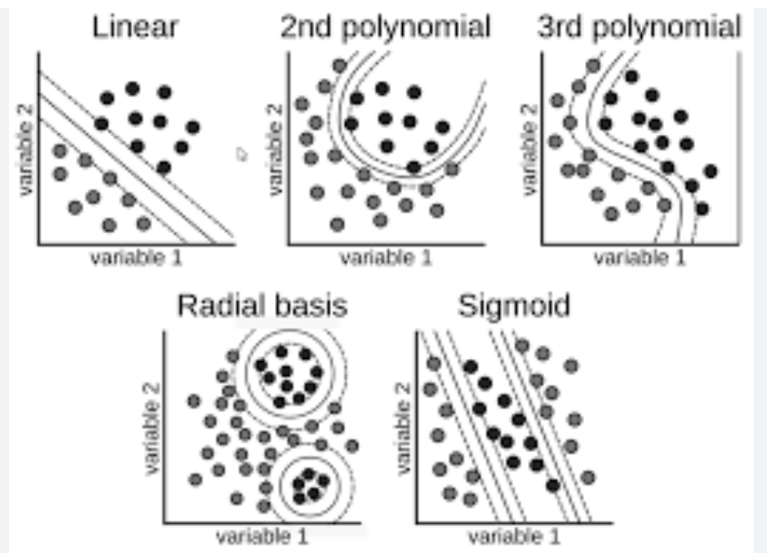

1. Linear Kernel:
   * The linear kernel is the simplest kernel and is equivalent to the standard SVM without transforming the data.
   * It is defined as: K(x, x') = x * x'
2. Polynomial Kernel:
   * The polynomial kernel allows fitting polynomial decision boundaries.
   * It is defined as: K(x, x') = (gamma * (x * x') + r)^d, where gamma and r are hyperparameters, and d is the degree of the polynomial.
3. Radial Basis Function (RBF) Kernel (Gaussian Kernel):
   * The RBF kernel can capture complex and non-linear decision boundaries.
   * It is defined as: K(x, x') = exp(-gamma * ||x - x'||^2), where gamma is a hyperparameter.
4. Sigmoid Kernel:
   * The sigmoid kernel is useful when dealing with neural networks and is defined as: K(x, x') = tanh(gamma * (x * x') + r), where gamma and r are hyperparameters.

Other custom kernels can also be used based on the characteristics of the data.

Using kernel functions, SVM can efficiently handle non-linear relationships in the data, making it a powerful and versatile algorithm for a wide range of classification tasks. However, the selection of the appropriate kernel and tuning its parameters (e.g., gamma for RBF kernel) is crucial for achieving good performance. Improper selection of the kernel and its parameters may lead to overfitting or poor generalization.

Kernel SVM is widely used in various applications, including image recognition, natural language processing, bioinformatics, and many other domains where non-linear relationships are prevalent in the data. It has become one of the fundamental tools in the machine learning toolkit for solving complex classification problems.

## Naïve Bayes

Naive Bayes classification is a simple and widely used supervised machine learning algorithm based on the Bayes theorem. It is particularly suited for text classification and other types of classification tasks involving discrete features. Despite its simplicity and "naive" assumption of feature independence, it can perform surprisingly well in practice, especially when dealing with large datasets.

The key idea behind Naive Bayes is to predict the class label of an input data point based on the probability of each class given the observed features. The algorithm assumes that all features are conditionally independent given the class label, which is why it is called "naive."

Here's how Naive Bayes classification works:

1. Training Phase:
   * Given a labeled training dataset, Naive Bayes estimates the prior probability of each class and the likelihood of each feature given each class.
   * The prior probability of a class is the proportion of data points in the training set belonging to that class.
   * The likelihood of a feature given a class is the probability of observing that feature value given the class label.
2. Prediction Phase:
   * For a new, unlabeled data point, Naive Bayes calculates the posterior probability of each class given the observed features using Bayes theorem.
   * The class with the highest posterior probability is selected as the predicted class for the new data point.

Mathematically, for a data point with features x = (x1, x2, ..., xn), and a set of class labels C = {c1, c2, ..., ck}, the Naive Bayes classifier predicts the class c* for the new data point by maximizing the posterior probability:

c* = argmax P(ci | x) = argmax P(ci) * P(x | ci)

Since Naive Bayes assumes independence between features, the likelihood term P(x | ci) can be calculated as the product of the individual feature probabilities:

P(x | ci) = P(x1 | ci) * P(x2 | ci) * ... * P(xn | ci)

The choice of the likelihood and prior probability estimation methods depends on the type of features. For continuous features, Gaussian Naive Bayes is commonly used, while for categorical features, Multinomial Naive Bayes is more appropriate. For binary features, Bernoulli Naive Bayes can be used.

Naive Bayes classification is efficient, fast, and robust to irrelevant features. However, its assumption of feature independence may not hold in all cases, which can lead to suboptimal performance on certain datasets. Nonetheless, it remains a popular choice for text classification tasks, spam filtering, sentiment analysis, and other applications involving discrete data.

Example:

Here's a small training dataset:

| **Rain** | **Temperature** | **Play Tennis** |
| --- | --- | --- |
| Yes | Hot | No |
| Yes | Hot | No |
| Yes | Mild | Yes |
| No | Mild | Yes |
| Yes | Cool | Yes |
| No | Cool | Yes |
| No | Mild | Yes |
| Yes | Hot | No |
| No | Mild | Yes |

Given this data, let's use Naive Bayes to predict whether to play tennis (Yes or No) for a new data point where it is raining (Yes) and the temperature is mild.

Step 1: Calculate the Prior Probabilities We need to calculate the prior probabilities P(Play Tennis=Yes) and P(Play Tennis=No).

* Number of "Yes" in Play Tennis: 5
* Number of "No" in Play Tennis: 4
* Total data points: 9

P(Play Tennis=Yes) = 5/9 ≈ 0.556 P(Play Tennis=No) = 4/9 ≈ 0.444

Step 2: Calculate Likelihood Probabilities Now, we calculate the likelihood probabilities for each feature given each class.

* For "Rain" feature:
  + P(Rain=Yes | Play Tennis=Yes) = 3/5 = 0.6
  + P(Rain=No | Play Tennis=Yes) = 2/5 = 0.4
  + P(Rain=Yes | Play Tennis=No) = 2/4 = 0.5
  + P(Rain=No | Play Tennis=No) = 2/4 = 0.5
* For "Temperature" feature:
  + P(Temperature=Mild | Play Tennis=Yes) = 3/5 = 0.6
  + P(Temperature=Mild | Play Tennis=No) = 2/4 = 0.5
  + Other values for Temperature are not present in the "No" class.

Step 3: Calculate Posterior Probabilities for the New Data Point Now, we use the Naive Bayes formula to calculate the posterior probabilities for each class given the new data point "Rain=Yes" and "Temperature=Mild".

For Class "Yes": P(Play Tennis=Yes | Rain=Yes, Temperature=Mild) ∝ P(Rain=Yes | Play Tennis=Yes) * P(Temperature=Mild | Play Tennis=Yes) * P(Play Tennis=Yes) ≈ 0.6 * 0.6 * 0.556 ≈ 0.1997

For Class "No": P(Play Tennis=No | Rain=Yes, Temperature=Mild) ∝ P(Rain=Yes | Play Tennis=No) * P(Temperature=Mild | Play Tennis=No) * P(Play Tennis=No) ≈ 0.5 * 0.5 * 0.444 ≈ 0.111

Step 4: Make the Prediction Since the posterior probability for Class "Yes" (0.1997) is higher than for Class "No" (0.111), we predict that the person will play tennis (Yes) given the new data point "Rain=Yes" and "Temperature=Mild".

Thus, the Naive Bayes classifier predicts "Yes" (Play Tennis) for the new data point.

## Decision Tree

Decision tree classification is a popular supervised machine learning algorithm used for both binary and multi-class classification tasks. It is based on a hierarchical structure of decision nodes and leaf nodes, where each decision node corresponds to a feature, each branch represents a possible value of that feature, and each leaf node represents a class label.

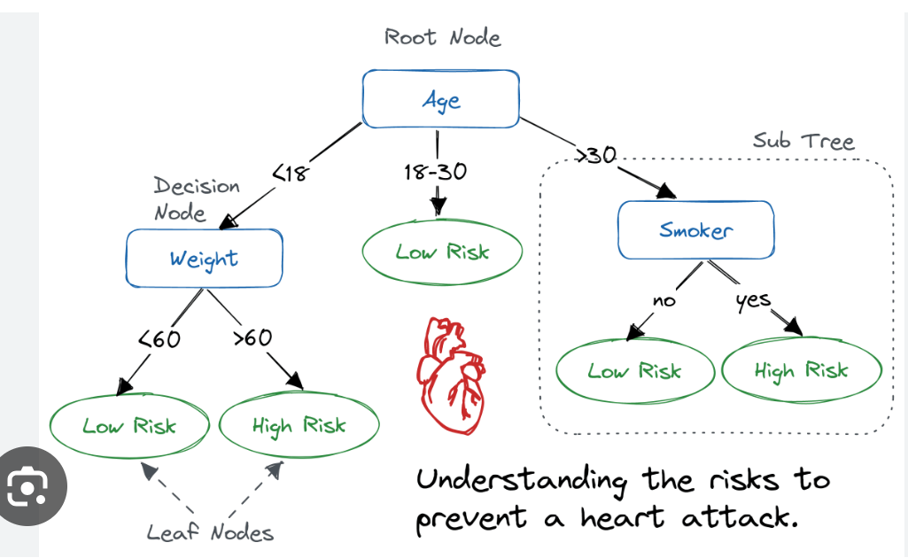

The decision tree classification process can be summarized as follows:

1. Training Phase:
   * Given a labeled training dataset, the decision tree algorithm recursively splits the data into subsets based on the feature that best separates the data at each node.
   * The process starts with the root node, which includes all the training data, and then proceeds to split the data into subsets at each subsequent node based on the chosen feature and threshold (for continuous features) or value (for categorical features) that maximizes the information gain or other criteria.
   * The algorithm continues this splitting process until a stopping criterion is met, such as reaching a maximum depth, having a minimum number of samples at a node, or achieving pure leaf nodes (nodes with samples of the same class).
2. Prediction Phase:
   * For a new, unlabeled data point, the decision tree algorithm starts at the root node and traverses the tree based on the values of the features in the data point.
   * At each node, the algorithm follows the branch corresponding to the value of the feature in the data point and proceeds to the next node.
   * Once it reaches a leaf node, the class label associated with that leaf node is assigned as the predicted class label for the new data point.

The decision tree algorithm uses various metrics to evaluate the best feature to split the data at each node. Common metrics include Gini impurity (used in CART - Classification and Regression Trees) and information gain (used in ID3 - Iterative Dichotomiser 3 and C4.5 algorithms).

Decision trees are interpretable and can handle both categorical and numerical features. They are especially useful for feature selection, as they rank the importance of features based on their position in the tree. However, decision trees can suffer from overfitting, especially when they become deep and complex. To address this, ensemble methods like Random Forests and Gradient Boosting Trees are often used to improve the model's performance and generalization.

## Evaluating Classification Models

1. Accuracy:
   * Accuracy measures the proportion of correctly classified instances out of the total instances in the dataset. It is a basic metric for overall performance.
   * Accuracy = (Number of Correctly Classified Instances) / (Total Number of Instances)

Accuracy Paradox: If there is one class in dataset that comes more often, predicting that class always will result in higher accuracy.

1. Precision, Recall, and F1-score:
   * Precision (also called Positive Predictive Value) is the proportion of true positive predictions out of all positive predictions made by the model.
   * Recall (also called Sensitivity or True Positive Rate) is the proportion of true positive predictions out of all actual positive instances in the dataset.
   * F1-score is the harmonic mean of precision and recall, which provides a balance between the two metrics.
   * Precision = True Positives / (True Positives + False Positives)
   * Recall = True Positives / (True Positives + False Negatives)
   * F1-score = 2 * (Precision * Recall) / (Precision + Recall)
2. Confusion Matrix:

|  | **Predicted Positive** | **Predicted Negative** |
| --- | --- | --- |
| Actual Positive | True Positive (TP) | False Negative (FN) |
| Actual Negative | False Positive (FP) | True Negative (TN) |

* + The confusion matrix provides a comprehensive summary of the model's performance, showing the number of true positive, false positive, true negative, and false negative predictions.
  + It is helpful in calculating other metrics like precision, recall, and accuracy.

1. ROC Curve and AUC-ROC:

* The Receiver Operating Characteristic (ROC) curve is a graphical representation of the model's performance across various classification thresholds.
* The Area Under the ROC Curve (AUC-ROC) is a metric that quantifies the overall performance of the model in distinguishing between the positive and negative classes. Higher AUC-ROC values indicate better performance.

1. Precision-Recall Curve and AUC-PR:

* The Precision-Recall (PR) curve is a graphical representation of the trade-off between precision and recall at different classification thresholds.
* The Area Under the Precision-Recall Curve (AUC-PR) is another metric that summarizes the model's performance, especially in imbalanced datasets.

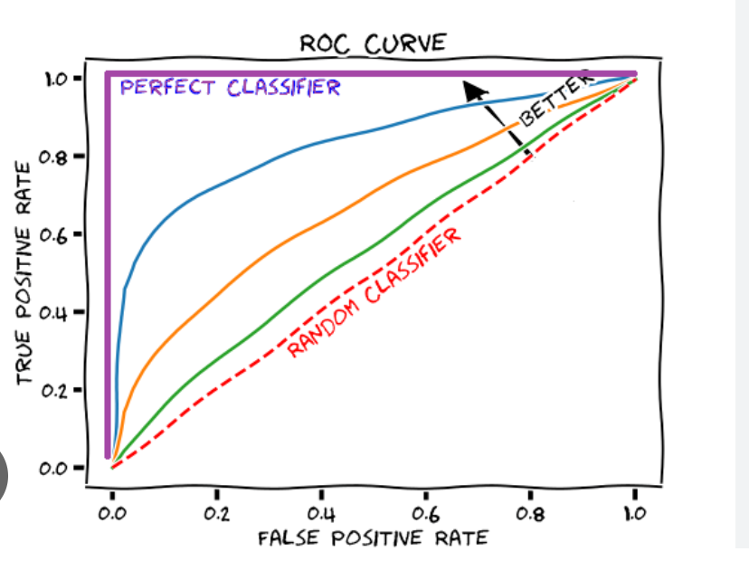

True Positive Rate (TPR) or Sensitivity: TPR is the proportion of true positive predictions (correctly predicted positive instances) out of all actual positive instances in the dataset. It is calculated as:

TPR = True Positives / (True Positives + False Negatives)

False Positive Rate (FPR): FPR is the proportion of false positive predictions (incorrectly predicted positive instances) out of all actual negative instances in the dataset. It is calculated as:

FPR = False Positives / (False Positives + True Negatives)

1. Cohen's Kappa:
   * Cohen's Kappa is a measure of the agreement between the model's predictions and the true labels, taking into account the possibility of random agreement.
   * It is useful for assessing the model's performance when the class distribution is imbalanced.
2. Classification Report:
   * The classification report provides a summary of various metrics, including precision, recall, F1-score, and support (the number of occurrences of each class) for each class in the dataset.

When evaluating classification models, it's essential to consider the specific requirements of the problem and the domain. For example, in medical diagnosis, recall (sensitivity) might be more critical to avoid false negatives (missed cases), while in spam detection, precision might be more important to minimize false positives (legitimate emails classified as spam). Also, cross-validation or using a separate test dataset is recommended to ensure the model's generalization performance.

### CAP Curve

he Cumulative Accuracy Profile (CAP) curve is a graphical representation used to evaluate the performance of a binary classification model, particularly in marketing and business-related applications. The CAP curve provides insights into how well the model is performing in terms of capturing the positive instances in the dataset.

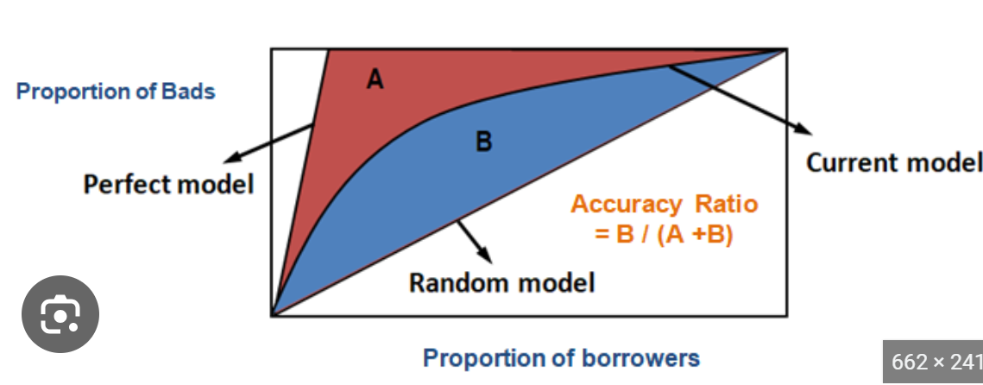

Accuracy = Area between current and random model/area between perfect and random model

The CAP curve is constructed as follows:

1. First, the dataset is sorted based on the model's predicted probabilities for the positive class (e.g., the probability of a customer making a purchase or responding to an offer).
2. Next, the sorted dataset is divided into equal intervals (bins) from 0% to 100% of the total instances. Each bin contains an equal number of data points.
3. Within each bin, the cumulative number of actual positive instances (cumulative true positives) is plotted on the y-axis, and the cumulative number of instances in that bin (cumulative total instances) is plotted on the x-axis.
4. The baseline or random model is plotted as a straight line on the CAP curve. The baseline represents the cumulative number of positive instances if predictions were made randomly without any model.
5. The CAP curve shows the proportion of the total positive instances captured by the model at different levels of cumulative total instances. The closer the CAP curve is to the top-left corner, the better the model's performance.

The CAP curve is beneficial in assessing the model's ability to rank the instances correctly and in comparing the model's performance with a random or baseline model. The performance of the model can be quantified by calculating the Area Under the CAP Curve (AUC-CAP). The AUC-CAP value ranges from 0 to 1, with a higher value indicating better performance.

An ideal model with perfect ranking would have an AUC-CAP of 1, meaning it captures all the positive instances before reaching the total number of instances equal to the total positive instances. A random model has an AUC-CAP of 0.5, as it captures positive instances in proportion to their prevalence in the dataset.

# Clustering

## K Means Clustering

K-means clustering is a popular unsupervised machine learning algorithm used for partitioning data points into K clusters. The algorithm aims to minimize the sum of squared distances between data points and their respective cluster centroids. The steps of the K-means algorithm are as follows:

a. Choose the number of clusters, K. b. Randomly initialize K cluster centroids. c. Assign each data point to the nearest cluster centroid. d. Recalculate the cluster centroids by taking the mean of all the points assigned to each cluster. e. Repeat steps c and d until convergence or a maximum number of iterations.

K-means is an iterative algorithm, and it may converge to different solutions depending on the initial random centroids.

**Random Initialization Trap:** The random initialization trap refers to the sensitivity of the K-means algorithm to the initial random placement of cluster centroids. Since K-means starts with random centroids, different initializations may lead to different final clusterings and, in some cases, suboptimal solutions. It is possible that K-means gets stuck in local minima, leading to less accurate clustering results.

To overcome the random initialization trap, it is a common practice to run the K-means algorithm multiple times with different random initializations and then choose the clustering with the lowest sum of squared distances (also known as "inertia") as the final result. However, even with this approach, there is no guarantee of finding the globally optimal clustering, especially in high-dimensional or complex data.

**Elbow Method:** The Elbow Method is a graphical technique used to determine the optimal number of clusters, K, in K-means clustering. It helps to find a balance between the number of clusters and the sum of squared distances within each cluster (inertia). The general idea behind the Elbow Method is that as you increase the number of clusters, the inertia will decrease, and each data point will be closer to its cluster centroid. However, adding more clusters can lead to overfitting and less meaningful clustering.

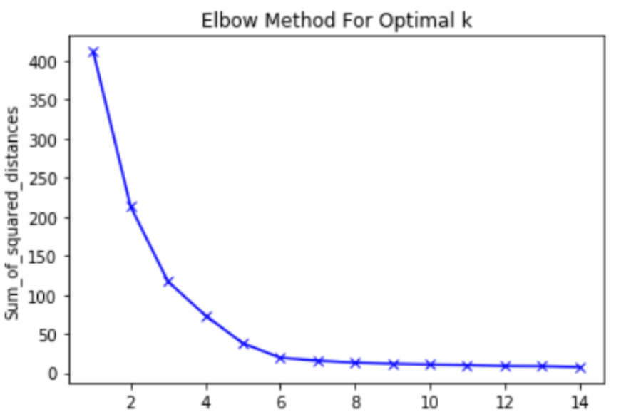

## Hierarchial Clustering

Hierarchical clustering is another popular unsupervised machine learning technique used for clustering data. It is different from K-means clustering in that it creates a tree-like structure of nested clusters, known as a dendrogram, which can be helpful in visualizing the relationships between clusters.

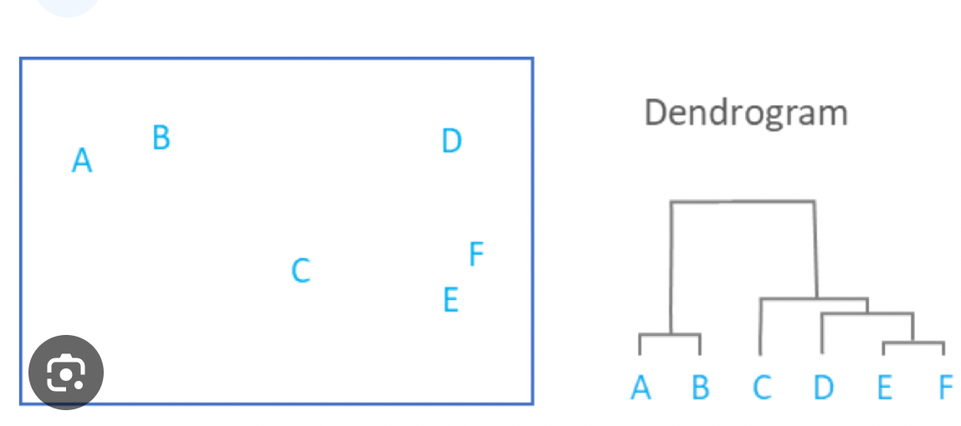

There are two main types of hierarchical clustering:

1. Agglomerative Hierarchical Clustering:
   * In this approach, each data point starts as its own cluster.
   * At each step, the two closest clusters are merged into a new larger cluster.
   * The process continues until all data points belong to a single cluster or a specified number of clusters is reached.
   * The result is a dendrogram that shows the merging process and the hierarchical relationship between clusters.
2. Divisive Hierarchical Clustering:
   * This approach starts with all data points in one cluster.
   * At each step, the algorithm recursively splits the clusters into smaller clusters until each data point forms its own cluster or a specified number of clusters is reached.
   * The result is also a dendrogram, but in this case, it shows the splitting process.

To determine which clusters to merge or split, hierarchical clustering uses a distance metric to measure the similarity or dissimilarity between data points or clusters. Common distance metrics include Euclidean distance, Manhattan distance, and Pearson correlation coefficient, among others.

Hierarchical clustering has the advantage of providing a complete hierarchy of clusters, which allows for more flexibility in choosing the number of clusters at different levels of granularity. Additionally, it is not sensitive to initializations like K-means since it is a deterministic algorithm.

However, hierarchical clustering can be computationally expensive, especially for large datasets, as it requires calculating and storing distance matrices. The choice of linkage criteria (e.g., single-linkage, complete-linkage, average-linkage) can also impact the final clustering result, and different linkage methods may yield different outcomes.

To obtain a specific number of clusters from a dendrogram, you can cut the dendrogram at a desired level to create the required number of clusters. The horizontal axis represents the distance (or similarity) between clusters, and the vertical axis represents the individual data points or cluster labels.

# Association Rule Learning

## Apriori

Association rule learning, particularly the Apriori algorithm, is a popular technique used in data mining and market basket analysis to discover interesting relationships between items in a dataset. It aims to find frequent itemsets and generate association rules based on their occurrence.

Here's how the Apriori algorithm works:

1. Frequent Itemset Generation:
   * Apriori starts by scanning the dataset to find the support count of each item (i.e., the number of times it appears in the dataset). Support is a user-defined threshold that represents the minimum number of occurrences an itemset must have to be considered "frequent."
   * Itemsets that meet the support threshold are called "frequent itemsets." Frequent itemsets of size 1 are referred to as "frequent 1-itemsets."
2. Join Step:
   * Apriori generates candidate itemsets of size k+1 from frequent k-itemsets. To do this, it performs a join operation, where it combines two frequent itemsets of size k that share the same first (k-1) items. This process reduces the number of potential candidates, as only those candidate itemsets are considered that have a chance to be frequent.
3. Prune Step:
   * After generating candidate itemsets, Apriori prunes those candidates that have any subset of size k that is not a frequent (k-1)-itemset. This pruning step ensures that only promising candidates are retained for the next iteration.
4. Repeat:
   * Steps 2 and 3 are repeated iteratively until no new frequent itemsets can be generated or until a specified maximum itemset size is reached.

Once the frequent itemsets are obtained, Apriori derives association rules from them based on user-defined measures such as support, confidence, and lift.

* Support: The support of an itemset is the proportion of transactions that contain that itemset. It measures the frequency of occurrence of the itemset in the dataset.
* Confidence: The confidence of an association rule A -> B is the proportion of transactions that contain both A and B compared to the transactions that contain A. It measures the reliability of the rule.
* Lift: The lift of an association rule A -> B is the ratio of the confidence of the rule to the expected confidence if A and B were independent. Lift > 1 indicates a positive correlation between A and B.

By setting appropriate thresholds for support, confidence, and lift, you can filter out less interesting or irrelevant rules and focus on significant associations between items.

Keep in mind that the Apriori algorithm can be computationally intensive, especially for large datasets, as it involves multiple passes over the data and the generation of a large number of candidate itemsets. However, its efficiency can be improved by using optimizations and data structures like hash tables

Example

Transaction 1: {Milk, Bread, Eggs}

Transaction 2: {Milk, Juice, Sugar}

Transaction 3: {Bread, Juice}

Transaction 4: {Milk, Bread, Juice, Sugar}

Transaction 5: {Bread, Eggs}

We will use the Apriori algorithm to find frequent itemsets with a minimum support of 2 and generate association rules with a minimum confidence of 50%.

**Step 1: Frequent Itemset Generation (k=1)**

The support count for each item:

* Milk: 3
* Bread: 4
* Eggs: 2
* Juice: 3
* Sugar: 2

Frequent 1-itemsets: {Milk}, {Bread}, {Eggs}, {Juice}, {Sugar}

**Step 2: Join Step (k=2)**

We combine the frequent 1-itemsets to create candidate 2-itemsets:

{Milk, Bread}, {Milk, Eggs}, {Milk, Juice}, {Milk, Sugar}, {Bread, Eggs}, {Bread, Juice}, {Bread, Sugar}, {Eggs, Juice}, {Eggs, Sugar}, {Juice, Sugar}

**Step 3: Prune Step (k=2)**

We check the support count for each candidate 2-itemset:

* {Milk, Bread}: 2 (Frequent)
* {Milk, Eggs}: 1 (Not frequent)
* {Milk, Juice}: 2 (Frequent)
* {Milk, Sugar}: 1 (Not frequent)
* {Bread, Eggs}: 1 (Not frequent)
* {Bread, Juice}: 2 (Frequent)
* {Bread, Sugar}: 1 (Not frequent)
* {Eggs, Juice}: 1 (Not frequent)
* {Eggs, Sugar}: 0 (Not frequent)
* {Juice, Sugar}: 1 (Not frequent)

Frequent 2-itemsets: {Milk, Bread}, {Milk, Juice}, {Bread, Juice}

**Step 4: Join Step (k=3)**

We combine the frequent 2-itemsets to create candidate 3-itemsets:

{Milk, Bread, Juice}

**Step 5: Prune Step (k=3)**

We check the support count for the candidate 3-itemset:

* {Milk, Bread, Juice}: 1 (Not frequent)

Frequent 3-itemsets: None

**Association Rules Generation:**

Now, we generate association rules from the frequent itemsets with a minimum confidence of 50%.

* From {Milk, Bread} to {Juice}:
  + Support: 2
  + Confidence: Support({Milk, Bread, Juice}) / Support({Milk, Bread}) = 1 / 2 = 0.5 (50%)
* From {Milk, Juice} to {Bread}:
  + Support: 2
  + Confidence: Support({Milk, Bread, Juice}) / Support({Milk, Juice}) = 1 / 2 = 0.5 (50%)
* From {Bread, Juice} to {Milk}:
  + Support: 2
  + Confidence: Support({Milk, Bread, Juice}) / Support({Bread, Juice}) = 1 / 2 = 0.5 (50%)

## ECLAT

ECLAT (Equivalence Class Clustering and Bottom-Up Lattice Traversal) is another popular algorithm for mining frequent itemsets in transactional databases. Similar to Apriori, ECLAT is used for association rule learning and aims to find sets of items that frequently co-occur together in the dataset.

The main advantage of ECLAT over Apriori is its efficiency in terms of memory usage and runtime, especially for datasets with high dimensionality. ECLAT achieves this efficiency by using a depth-first search approach and vertical data format.

Here's how the ECLAT algorithm works:

1. Vertical Data Format:
   * In the vertical data format, the transactions are represented as a list of items along with the transactions in which they appear. Each item is associated with a list of transaction IDs (TIDs) containing the transactions where it appears.
2. Frequent Itemset Generation:
   * ECLAT starts with each item as a 1-itemset and computes its support (the number of transactions containing the item). It uses this support to identify frequent 1-itemsets.
3. Depth-First Search (DFS):
   * ECLAT performs a depth-first search to explore larger itemsets using frequent 1-itemsets as starting points.
   * For each frequent 1-itemset, ECLAT finds other frequent itemsets by intersecting their TID lists.
   * When it finds a new frequent itemset, it recursively explores its extensions.
4. Association Rule Generation:
   * Once frequent itemsets are identified, association rules are generated based on user-defined measures like support, confidence, or lift.

ECLAT efficiently prunes the search space by avoiding the need to generate and store the candidate itemsets explicitly, which is one of the main causes of memory inefficiency in the Apriori algorithm.

Though ECLAT is efficient for high-dimensional datasets, it may become less efficient when dealing with datasets with a large number of transactions or a small number of items. In such cases, other algorithms like FP-Growth (Frequent Pattern Growth) might be more suitable.

# Reinforcement Learning

Reinforcement learning (RL) is a type of machine learning paradigm in which an agent learns to make decisions by interacting with an environment. The agent aims to maximize a cumulative reward signal over time by taking appropriate actions in different states of the environment. The core idea behind reinforcement learning is inspired by behavioral psychology and concepts of how organisms learn through trial and error.

Here are the key components of reinforcement learning:

1. Agent: The entity that learns from the environment and takes actions based on the information it receives.
2. Environment: The external context with which the agent interacts. It can be anything from a simulated game environment to a real-world scenario.
3. State: A specific configuration or representation of the environment at a particular time during the agent's interaction.
4. Action: The decisions made by the agent in response to the state of the environment. The agent selects actions based on a policy.
5. Policy: A strategy or a set of rules that govern the agent's decision-making process, determining which action to take in each state.
6. Reward: A scalar signal that indicates the immediate feedback the agent receives from the environment after taking an action. The goal of the agent is to maximize the cumulative reward over time.
7. Value Function: A function that estimates the expected cumulative reward from a particular state or state-action pair. It helps the agent assess the desirability of different states or actions.
8. Q-Function: A function that estimates the expected cumulative reward for taking a specific action in a given state and following a particular policy thereafter.
9. Exploration vs. Exploitation: Balancing the exploration of new actions to discover potentially better strategies and exploiting known actions to maximize short-term reward is crucial in reinforcement learning.

The learning process in RL often involves iteratively updating the agent's policy or value function based on the observed rewards and experiences gained during interactions with the environment. One popular algorithm for reinforcement learning is Q-Learning, which is used for solving Markov Decision Processes (MDPs) with discrete state and action spaces.

Reinforcement learning has found applications in various fields, such as robotics, game playing, autonomous vehicles, recommendation systems, and many more, where systems need to learn from their actions and optimize their behavior over time to achieve specific objectives

## Upper Confidence Bound(UCB)

UCB stands for Upper Confidence Bound, which is a popular algorithm used in the context of multi-armed bandit problems and reinforcement learning. In multi-armed bandit problems, an agent (or decision-maker) faces a set of options (or arms) and needs to decide which arms to pull to maximize its total reward over time.

The UCB algorithm is designed to balance exploration and exploitation. It assigns an upper confidence bound to each arm based on its past rewards and uncertainties. The intuition is that the agent should explore arms with uncertain rewards to gather more information while also exploiting arms that have shown promising rewards so far.

Here's a high-level overview of how the UCB algorithm works:

1. Initialization: Initialize the algorithm by assigning zero reward to each arm and setting the number of times each arm has been pulled to zero.
2. Exploration-Exploitation Tradeoff: For each time step t, calculate the upper confidence bound for each arm using a confidence interval formula that depends on the number of times the arm has been pulled and the accumulated rewards.
3. Action Selection: Select the arm with the highest upper confidence bound. This step balances exploration by selecting arms with higher uncertainty and exploitation by selecting arms that have shown higher rewards in the past.
4. Pull Arm and Observe Reward: Execute the selected arm, observe the reward from the environment, and update the reward and number of pulls for that arm.
5. Repeat: Continue this process over multiple time steps, iteratively refining the estimates of the arm rewards.

UCB is an efficient and widely used algorithm for solving multi-armed bandit problems. It has also been extended to more complex reinforcement learning settings, such as contextual bandits and partially observable environments.

Here's how the UCB1 algorithm works step by step:

1. Initialization:
   * Set the total number of arms, N = 3.
   * Initialize the number of times each arm is pulled, n_i = 0, for i in [1, N].
   * Initialize the accumulated reward for each arm, R_i = 0, for i in [1, N].
2. Exploration-Exploitation Tradeoff (for each time step t):
   * Calculate the upper confidence bound for each arm using the UCB1 formula: UCB_i = R_i / n_i + sqrt(2 * ln(t) / n_i)
   * The first term R_i / n_i represents the average reward obtained from arm i.
   * The second term sqrt(2 * ln(t) / n_i) is a measure of the uncertainty, and it increases with the number of times arm i is pulled (t) and decreases with the number of times arm i is pulled (n_i).
3. Action Selection:
   * At each time step t, select the arm with the highest UCB_i value, i.e., choose the arm with the highest upper confidence bound.
4. Pull Arm and Observe Reward:
   * Pull the selected arm.
   * Observe the reward from the environment (e.g., 1 for winning, 0 for losing).
   * Update the accumulated reward R_i for the chosen arm and increment the number of times n_i it has been pulled.
5. Repeat:
   * Continue steps 2 to 4 over multiple time steps, iteratively refining the estimates of the arm rewards.

Over time, the UCB1 algorithm will learn to balance exploration and exploitation and converge toward the arm with the highest true reward probability.

## Thompson Sampling

Thompson Sampling, also known as Bayesian Bandit or Probability Matching, is another popular algorithm used for solving multi-armed bandit problems. Similar to UCB, it is designed to balance exploration and exploitation to maximize the cumulative reward over time.

In Thompson Sampling, the algorithm maintains a probability distribution (usually a Beta distribution) for each arm, representing the uncertainty about the true reward probability of that arm. At each time step, the algorithm samples from these distributions and selects the arm with the highest sampled value. The idea is to explore arms with higher uncertainty and exploit arms that have shown promising rewards in the past, based on the sampled probabilities.

Here's how the Thompson Sampling algorithm works step by step:

1. Initialization:
   * Set the total number of arms, N = 3.
   * Initialize the parameters of the Beta distributions for each arm. Typically, you start with uniform priors, where both alpha and beta are set to 1 for each arm.
2. Sampling (for each time step t):
   * Sample a reward probability from each arm's Beta distribution.
   * Select the arm with the highest sampled reward probability.
3. Pull Arm and Observe Reward:
   * Pull the selected arm.
   * Observe the reward from the environment (e.g., 1 for winning, 0 for losing).
4. Update Probability Distribution:
   * Update the parameters of the Beta distribution for the chosen arm based on the observed reward:
     + If the reward was 1 (win), increment the alpha parameter of the Beta distribution for that arm.
     + If the reward was 0 (loss), increment the beta parameter of the Beta distribution for that arm.
5. Repeat:
   * Continue steps 2 to 4 over multiple time steps, iteratively refining the probability distributions for each arm.

Thompson Sampling has been shown to perform well in various scenarios and often achieves good regret (the difference between the expected reward of the optimal arm and the reward obtained by the algorithm) bounds. The algorithm's Bayesian nature allows it to handle uncertainty effectively and adapt to changes in the environment over time.

As with any bandit algorithm, the performance of Thompson Sampling may depend on the specific problem and reward distributions. It is a powerful and intuitive approach for multi-armed bandit problems and has seen applications in online advertising, recommendation systems, and clinical trials, among others.

# Natural Language Processing

## Cleaning Data

When working with text data in NLP, there are several general steps to follow, including data cleaning and text preprocessing. Here's a typical workflow:

1. Data Collection:
   * Gather the raw text data from various sources, such as websites, documents, social media, etc.
2. Data Cleaning:
   * Remove any unnecessary characters, special symbols, and numerical values that do not add meaning to the text.
   * Convert the text to lowercase to ensure consistency.
   * Remove punctuation marks.
   * Handle contractions and special characters appropriately (e.g., converting "don't" to "do not").
   * Remove any URLs or hyperlinks.
   * Handle any specific domain-related cleaning (e.g., HTML tags in web pages).
3. Tokenization:
   * Split the text into individual words or tokens. This is an essential step to process text at a more granular level.
4. Stopword Removal:
   * Remove common words like "the," "is," "and," etc., which are frequent but do not carry significant meaning. These are called stopwords.
5. Stemming or Lemmatization:
   * Reduce words to their base or root form to handle variations of words. For example, "running," "runs," and "ran" can be reduced to "run."
6. Text Normalization:
   * Handle cases like converting abbreviations to full words, correcting misspellings, or standardizing different spellings of the same word.
7. Feature Engineering:
   * Transform the processed text into numerical representations, such as the Bag-of-Words model or TF-IDF (Term Frequency-Inverse Document Frequency).
8. Vectorization:
   * Convert the features (text representations) into numerical vectors suitable for machine learning algorithms.
9. Model Training and Evaluation:
   * Use the numerical vectors as input to train various NLP models like sentiment analysis, text classification, topic modeling, etc.
   * Evaluate the model's performance using appropriate metrics.
10. Model Deployment (Optional):
    * Deploy the trained model in a real-world application or integrate it into a larger system.

Remember that the specific steps and techniques you apply may vary depending on the nature of your text data, the problem you are trying to solve, and the available resources. Additionally, some NLP tasks may require more advanced techniques, such as word embeddings or deep learning models like Recurrent Neural Networks (RNNs) and Transformers.

Top of Form

## Bag of Words Model

The Bag-of-Words (BoW) model is a simple and widely used technique in Natural Language Processing (NLP) for text representation. It converts a piece of text into a numerical vector by counting the occurrences of words in the text without considering grammar or word order. The name "Bag-of-Words" comes from the idea that the order of words is discarded, and only the frequency of each word is considered, as if all the words were thrown into a bag.

Here's how the Bag-of-Words model works:

1. Tokenization: The text is divided into individual words or tokens. Punctuation and capitalization are typically removed, and all words are converted to lowercase.
2. Vocabulary Creation: The unique words present in the entire corpus of text are collected, forming the vocabulary.
3. Word Frequency Count: For each document (text sample), the frequency of each word in the vocabulary is counted, resulting in a numerical vector representation.
4. Vectorization: Each document is represented as a vector, where the length of the vector is equal to the size of the vocabulary. The value in each dimension of the vector represents the frequency count of the corresponding word in the vocabulary.
5. Sparse Representation: Since most texts only contain a small subset of the entire vocabulary, the resulting vectors are often sparse, with many zero values.

Here's a simple example to illustrate the Bag-of-Words model:

Let's say we have three short documents:

Document 1: "I love NLP." Document 2: "NLP is fascinating." Document 3: "NLP is fun."

Vocabulary: [I, love, NLP, is, fascinating, fun]

Vector representation:

Document 1: [1, 1, 1, 0, 0, 0] Document 2: [0, 0, 1, 1, 1, 0] Document 3: [0, 0, 1, 1, 0, 1]

As you can see, each document is represented as a numerical vector based on the frequency count of the words in the vocabulary. This representation allows the documents to be compared or used as input to various machine learning algorithms for NLP tasks such as sentiment analysis, text classification, and information retrieval.

While the Bag-of-Words model is straightforward and easy to implement, it has limitations. It ignores the word order and semantic meaning of the words, leading to the loss of important context information. More advanced techniques like TF-IDF (Term Frequency-Inverse Document Frequency) and word embeddings like Word2Vec and GloVe address some of these limitations and are commonly used in modern NLP applications.

# Deep Learning

## Neuron

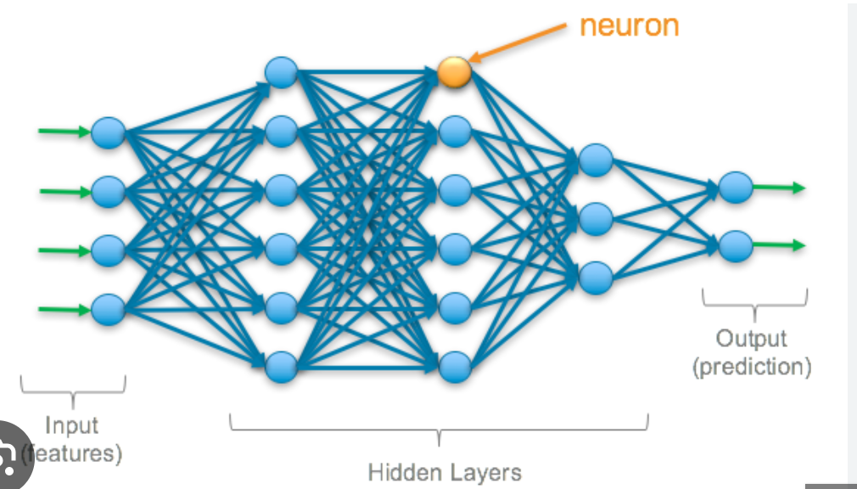

Here's a simplified representation of a neuron:

1. Inputs (x1, x2, ..., xn): Each neuron receives multiple input signals, represented as x1, x2, ..., xn. These inputs can be features from the input data or outputs from other neurons in the network.
2. Weights (w1, w2, ..., wn): Each input is associated with a weight, represented as w1, w2, ..., wn. Weights determine the importance of each input signal. During training, the neural network learns the optimal weights that influence the overall behavior of the neuron.
3. Bias (b): A bias term, represented as b, is added to the weighted sum of inputs. The bias allows the neuron to adjust the output along with the inputs and weights.
4. Weighted Sum (z): The weighted sum (z) of inputs and biases is computed as follows: z = (w1 * x1) + (w2 * x2) + ... + (wn * xn) + b
5. Activation Function (f(z)): The weighted sum is then passed through an activation function (f) to introduce non-linearity into the neuron's output. Activation functions allow neural networks to model complex relationships in data. Popular activation functions include sigmoid, tanh, ReLU (Rectified Linear Unit), and softmax.
6. Output (y): The final output of the neuron (y) is the result of the activation function applied to the weighted sum: y = f(z)

The process described above happens within a single neuron. However, in a deep neural network, neurons are organized into layers, with each layer consisting of multiple neurons. The output of one layer serves as input to the next layer, creating a hierarchical representation of data and allowing the network to learn complex patterns and features from the input data.

Deep learning models, such as deep neural networks, use large numbers of interconnected neurons and multiple layers to perform tasks like image recognition, natural language processing, speech recognition, and more. The ability of deep learning models to learn from large-scale data and discover intricate patterns has led to significant advancements in various fields.

Top of Form

## Activation Function

Activation functions are an essential component of artificial neural networks, including deep learning models. They introduce non-linearity to the output of individual neurons, allowing neural networks to model complex relationships and approximate non-linear functions. Activation functions play a crucial role in determining the output of a neuron based on its input and are an integral part of the forward pass in neural network computations.

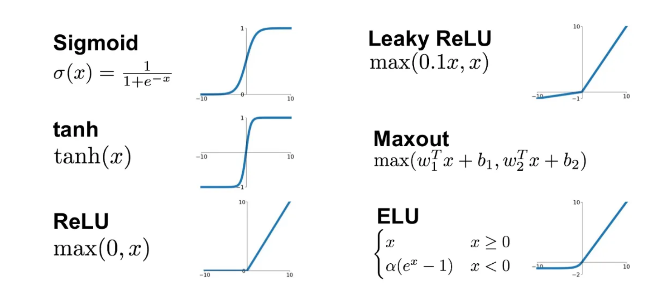

1. Sigmoid Activation (Logistic function):
   * Output range: (0, 1)
   * Pros: It was historically popular but is less used now due to some drawbacks.
   * Cons: The sigmoid function saturates, which means the gradients become very small for extreme input values, leading to vanishing gradients and slowing down learning.
2. Hyperbolic Tangent Activation (tanh):
   * Output range: (-1, 1)
   * Pros: Similar to the sigmoid but with an output range symmetric around 0, which helps mitigate vanishing gradients to some extent.
   * Cons: Still prone to vanishing gradients for very large or very small input values.
3. Rectified Linear Unit (ReLU):
   * Output range: [0, ∞)
   * Pros: Simple and computationally efficient. It helps avoid the vanishing gradient problem and accelerates learning in deep networks.
   * Cons: The "dying ReLU" problem can occur when neurons get stuck in a state where they always output 0 for any input, effectively becoming inactive.
4. Leaky ReLU:
   * Output range: (-∞, ∞)
   * Pros: Addresses the "dying ReLU" problem by introducing a small negative slope for negative input values, allowing neurons to recover from being inactive.
   * Cons: The choice of the slope parameter can be hyperparameter-dependent.
5. Parametric ReLU (PReLU):
   * Output range: (-∞, ∞)
   * Pros: Allows the network to learn the optimal slope for each neuron.
   * Cons: Slightly increases the number of parameters in the model.
6. Exponential Linear Unit (ELU):
   * Output range: (-α, ∞)
   * Pros: Addresses the vanishing gradient problem by introducing a negative saturation regime for negative input values.
   * Cons: Computationally more expensive compared to ReLU.
7. Threshold Activation Function:
   * Output range: {0, 1}
   * Pros: It can be useful for binary classification problems where the output should be binary, without any continuous values in between.
   * Cons: It does not allow the gradients to flow back for backpropagation, making it unsuitable for training deep neural networks.

## How NN Works

Here's a high-level overview of how a neural network works:

1. Input Layer: The input layer receives the input data, which can be any type of feature or data representation suitable for the problem at hand.
2. Weighted Sum: Each neuron in the hidden layers and output layer receives the inputs from the previous layer, multiplies them by associated weights, and computes the weighted sum of these inputs.
3. Activation Function: The weighted sum is then passed through an activation function, which introduces non-linearity to the output. This non-linearity is essential for the network to learn complex patterns and relationships in the data.
4. Forward Propagation: The process of passing the input data through the network, layer by layer, and producing the final output is called forward propagation. The output of the last layer represents the prediction made by the neural network for a given input.
5. Cost Function: The cost function (also called the loss function or objective function) measures the difference between the predicted output and the actual target values. The goal is to minimize this difference during training.
6. Gradient Descent: Gradient descent is an optimization algorithm used to update the weights of the neural network to minimize the cost function. It calculates the gradients of the cost function with respect to the weights and updates the weights in the direction that reduces the cost.
7. Backpropagation: The process of computing the gradients of the cost function with respect to the weights, layer by layer, is called backpropagation. It efficiently computes the gradients by applying the chain rule of calculus.
8. Training: The neural network is trained using labeled training data, where the input data is paired with the corresponding target values. The weights are iteratively updated using gradient descent, and the process is repeated over multiple epochs (passes through the entire dataset) until the model converges to a satisfactory solution.
9. Evaluation: Once the neural network is trained, it can be used to make predictions on new, unseen data. The model's performance is evaluated using metrics relevant to the specific problem, such as accuracy, precision, recall, or mean squared error.

The process of training a neural network involves finding the optimal set of weights that minimizes the cost function and allows the network to make accurate predictions on new data. The training process is computationally intensive and often requires large amounts of labeled data. Modern deep learning frameworks and hardware acceleration have significantly facilitated the training of complex neural network architectures on massive datasets, leading to remarkable advancements in various fields.

Simple Example:

Let's say we want to create a neural network that can approximate the XOR function, which takes two binary inputs (0 or 1) and returns 1 if only one of the inputs is 1 and 0 otherwise.

Here's the architecture of the neural network:

Input layer: 2 neurons (for two binary inputs, x1 and x2). Hidden layer: 2 neurons (can be any number you choose). Output layer: 1 neuron (for the XOR output, y).

Let's assume the hidden layer neurons have weights and biases as follows:

For Hidden Neuron 1:

* Weight for x1: 0.6
* Weight for x2: 0.9
* Bias: -1.2

For Hidden Neuron 2:

* Weight for x1: 0.4
* Weight for x2: -0.8
* Bias: 0.6

The output neuron has weights and a bias as follows:

For Output Neuron:

* Weight for Hidden Neuron 1: 1.1
* Weight for Hidden Neuron 2: -1.3
* Bias: 0.1

Now, let's calculate the output of this neural network for an example input (x1 = 1, x2 = 0):

1. Calculate the outputs of hidden layer neurons: Hidden Neuron 1 output = sigmoid(0.6 * 1 + 0.9 * 0 - 1.2) ≈ sigmoid(-0.6) ≈ 0.354 Hidden Neuron 2 output = sigmoid(0.4 * 1 - 0.8 * 0 + 0.6) ≈ sigmoid(1) ≈ 0.731

(Note: The sigmoid function converts the sum of weighted inputs to a value between 0 and 1.)

1. Calculate the output of the final neuron (the XOR output): Output = sigmoid(1.1 * 0.354 - 1.3 * 0.731 + 0.1) ≈ sigmoid(-0.541) ≈ 0.368

The final output of the neural network for input (x1 = 1, x2 = 0) is approximately 0.368. You can repeat this process for other inputs to approximate the XOR function. In a real-world scenario, you would use a training dataset and adjust the weights and biases through an optimization algorithm like gradient descent to improve the network's performance.

## Gradient Descent

Gradient descent is an iterative optimization algorithm used to find the minimum of a function, particularly in the context of machine learning and neural networks. It is widely used for updating the parameters (weights and biases) of a model to minimize a cost function that measures the difference between predicted values and actual target values. The goal of gradient descent is to find the optimal values of the model's parameters that result in the lowest possible cost.

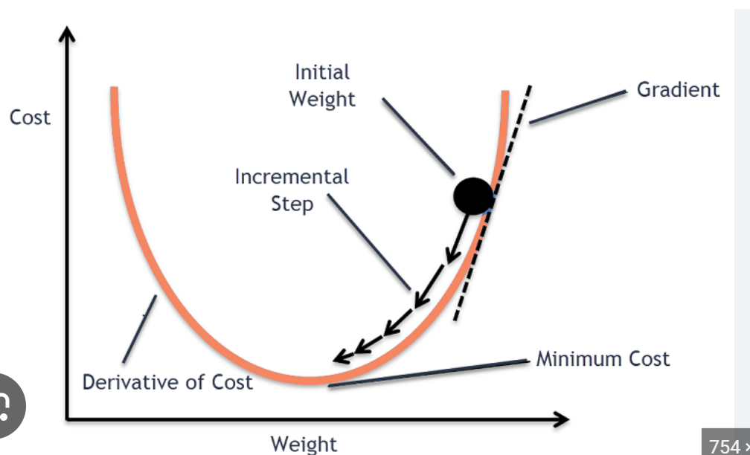

The algorithm gets its name from the idea of moving in the direction of the steepest descent (i.e., the negative gradient) of the cost function with respect to the model's parameters. The gradient represents the rate of change of the cost function concerning each parameter. By iteratively updating the parameters in the direction of the negative gradient, gradient descent aims to reach the minimum of the cost function, where the model's predictions are the most accurate.

Here's the high-level description of how gradient descent works:

1. Initialization: Initialize the model's parameters randomly or with some pre-defined values.
2. Forward Propagation: Feed the input data through the model to make predictions.
3. Calculate Cost: Compute the cost function that quantifies the difference between the predicted values and the actual target values.
4. Backpropagation: Calculate the gradients of the cost function with respect to each parameter using the chain rule of calculus. This is also known as backpropagation, as it involves propagating the error backward through the layers of the neural network.
5. Update Parameters: Update the model's parameters (weights and biases) using the calculated gradients and the learning rate. The learning rate is a hyperparameter that controls the step size of the parameter updates. A smaller learning rate results in slower convergence but may lead to more stable training, while a larger learning rate can speed up convergence but may cause oscillations or overshooting.
6. Repeat Steps 2 to 5: Continue the process of forward propagation, cost calculation, backpropagation, and parameter updates for a certain number of iterations (epochs) or until the cost function reaches a satisfactory value.

The gradient descent algorithm iteratively adjusts the model's parameters in the direction of the steepest decrease in the cost function. As a result, the model learns to make better predictions, and the cost function gradually decreases during the training process. When the algorithm converges, the parameters reach values that minimize the cost function, providing a well-trained model.

There are variations of gradient descent, such as stochastic gradient descent (SGD), mini-batch gradient descent, and adaptive learning rate methods (e.g., Adam and RMSprop), which aim to improve the convergence speed and overall performance of the optimization process. Gradient descent forms the basis for training various machine learning models, especially deep neural networks, where it plays a critical role in updating the large number of parameters involved in these complex models.

### Stochastic Gradient Descent

Stochastic Gradient Descent (SGD) is an optimization algorithm commonly used to train machine learning models, including neural networks. It is a variant of the gradient descent algorithm and is particularly well-suited for large datasets. Here are the steps involved in stochastic gradient descent:

1. **Initialize Parameters**: Initialize the model's parameters randomly. These parameters include weights and biases for each neuron in the neural network.
2. **Set Hyperparameters**: Set the learning rate (step size), the number of epochs (iterations over the entire dataset), and other hyperparameters. The learning rate determines the size of the steps taken during parameter updates.
3. **Shuffle the Dataset**: Shuffle the training dataset randomly. This is important to prevent the algorithm from getting biased by the order of the samples during training.
4. **Iterate over Mini-batches**: Divide the shuffled dataset into mini-batches. Each mini-batch consists of a small subset of the training data (usually in the range of tens to hundreds of samples). The choice of mini-batch size can impact the performance and speed of convergence.
5. **Update Parameters for Each Mini-batch**: For each mini-batch, do the following: a. Forward Propagation: Feed the mini-batch through the neural network to obtain predictions (forward pass). b. Compute Loss: Calculate the loss between the predicted outputs and the true labels. c. Backward Propagation: Compute the gradients of the loss with respect to the model's parameters (backward pass). d. Update Parameters: Update the model's parameters using the computed gradients and the learning rate. The general formula for parameter update is: new_parameter = old_parameter - (learning_rate * gradient).
6. **Repeat**: Continue iterating over mini-batches and updating the parameters until all mini-batches have been used (one full pass over the training dataset). This is known as one epoch. You can repeat this process for multiple epochs to improve the model's performance.
7. **Evaluate the Model**: After training, use a separate validation or test dataset to evaluate the model's performance on unseen data. This helps in assessing how well the model generalizes to new examples.
8. **Adjust Hyperparameters**: If the model's performance is not satisfactory, you may need to tune the hyperparameters (learning rate, batch size, number of epochs, etc.) or even consider using more advanced optimization techniques.
9. **Finalize the Model**: Once the model achieves satisfactory performance on the validation set, you can finalize it and use it for making predictions on new data.

## Convolution Neural Network

A Convolutional Neural Network (CNN or ConvNet) is a specialized type of neural network designed to process and analyze visual data, such as images and videos. CNNs are widely used in computer vision tasks like image classification, object detection, segmentation, and more. They have been highly successful in various applications due to their ability to automatically learn hierarchical features from raw pixel data.

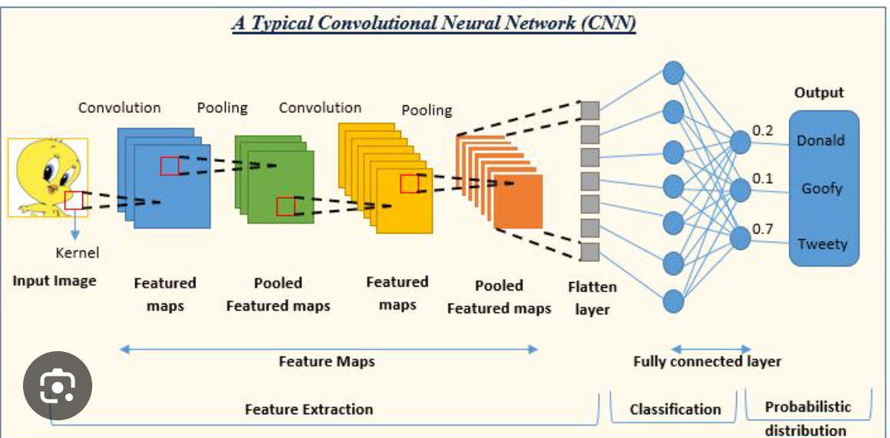

Key components of a Convolutional Neural Network:

1. **Convolutional Layers**: These are the fundamental building blocks of a CNN. Convolutional layers apply filters (also known as kernels) to the input data (e.g., an image) to detect specific features like edges, patterns, or textures. During training, the network learns the values of these filters to detect relevant patterns in the data. Multiple filters can be applied simultaneously to produce feature maps.
2. **Activation Function**: After each convolutional operation, an activation function (typically ReLU - Rectified Linear Unit) is applied element-wise to introduce non-linearity. ReLU helps the network learn complex patterns and makes the learning process more efficient.
3. **Pooling Layers**: Pooling layers downsample the spatial dimensions of the feature maps to reduce computation and control overfitting. Common pooling operations include max pooling, which takes the maximum value in a local region, and average pooling, which computes the average value.
4. **Fully Connected Layers**: These layers are typically used in the latter part of the network to perform classification or regression. Fully connected layers take the high-level features extracted by the convolutional layers and use them to make predictions.
5. **Flattening**: Before passing the features to the fully connected layers, the feature maps are flattened into a 1-dimensional vector.
6. **Softmax Layer**: In classification tasks, a softmax layer is used to produce probability scores for each class. The output values are normalized to represent the probability of each class, and the class with the highest probability is considered the final prediction.

The general flow of data through a CNN is as follows: Input (e.g., an image) -> Convolutional Layers -> Activation Function -> Pooling Layers -> Flattening -> Fully Connected Layers -> Softmax Layer (for classification)

CNNs employ parameter sharing and weight sharing, which reduces the number of parameters compared to fully connected neural networks, making them efficient in processing large visual datasets.

Pre-trained CNN architectures, such as VGG, ResNet, and Inception, are available and widely used for various tasks. Transfer learning, where you take a pre-trained model and fine-tune it on a specific task, is a common approach to leverage these powerful architectures even with limited data.

# Dimensionality Reduction

## Principal Component Analysis

Principal Component Analysis (PCA) is a widely used technique in statistics and machine learning for reducing the dimensionality of high-dimensional data while preserving most of the essential information. It's commonly employed for data visualization, noise reduction, and feature extraction.

The main idea behind PCA is to transform the original features into a new set of uncorrelated variables, known as principal components. These components are ranked in order of the amount of variance they explain in the data. The first principal component explains the most variance, the second one explains the second most, and so on.

Here's a step-by-step explanation of how PCA works:

1. Data Standardization: PCA begins by standardizing the data, i.e., subtracting the mean and scaling the features to have unit variance. This step is essential to ensure that features with larger scales don't dominate the analysis.
2. Covariance Matrix: After standardization, PCA computes the covariance matrix, which represents the relationships between different features. The covariance between two features measures how they vary together.
3. Eigendecomposition: The next step is to find the eigenvalues and eigenvectors of the covariance matrix. The eigenvectors represent the principal components, and the corresponding eigenvalues indicate the amount of variance explained by each component.
4. Selecting Principal Components: The eigenvectors are sorted based on their eigenvalues in descending order. The number of principal components to retain is typically decided based on how much variance you want to preserve. A common approach is to choose enough components to explain a certain percentage of the total variance (e.g., 95%).
5. Projection: The final step is to project the data onto the selected principal components. This process creates a new feature space with reduced dimensions, but the essential information is still retained.

By using PCA, you can simplify complex data sets, visualize high-dimensional data in lower dimensions, and potentially improve the performance of machine learning algorithms by reducing the number of features while preserving important patterns.

### Kernel PCA

Kernel PCA (Principal Component Analysis) is a nonlinear extension of the standard PCA method that allows for dimensionality reduction and feature extraction in cases where the data is not linearly separable. It is particularly useful when dealing with data that exhibits complex, nonlinear structures.

## Linear Discriminant Analysis

The main goal of LDA is to project the data into a lower-dimensional space while preserving the class-related information as much as possible. It works well when there is a clear separation between different classes and can be used for both binary and multiclass classification problems.

Here's a step-by-step explanation of how Linear Discriminant Analysis works:

1. Data Preprocessing: As with PCA, LDA often begins with standardizing the data to have zero mean and unit variance. This step is crucial for the optimal performance of LDA.
2. Compute Class Means: For each class in the data, LDA calculates the mean vector of the feature values. These mean vectors represent the centroids of each class in the original feature space.
3. Compute Scatter Matrices: LDA computes two scatter matrices: within-class scatter matrix (Sw) and between-class scatter matrix (Sb).
   * Within-Class Scatter Matrix (Sw): Sw measures the spread of data points within each class. It is the sum of the covariance matrices of individual classes.
   * Between-Class Scatter Matrix (Sb): Sb quantifies the differences between class means. It is the sum of the products of the differences between class means and their transpose.
4. Compute Eigenvectors and Eigenvalues: LDA then finds the eigenvectors and eigenvalues of the matrix Sw^(-1) * Sb. These eigenvectors represent the directions (linear discriminants) that best separate the classes.
5. Select Discriminant Components: The eigenvectors are ranked based on their corresponding eigenvalues. Typically, the number of discriminant components to retain is equal to the number of classes minus one (C-1), where C is the number of classes. These discriminant components are the new axes along which the data is projected.
6. Projection: The final step is to project the data onto the selected discriminant components to obtain the lower-dimensional representation of the data.

# Model Selection and Boosting

## K Cross Fold Validation

Model selection is a crucial step in machine learning, as it involves choosing the best model or algorithm that performs well on unseen data. Cross-validation, specifically k-fold cross-validation, is a popular technique used for model selection and hyperparameter tuning.

K-fold cross-validation involves the following steps:

1. Data Splitting: The original dataset is divided into k subsets of roughly equal size. These subsets are often referred to as "folds."
2. Model Training and Evaluation: The model is trained and evaluated k times. In each iteration, one of the k folds is used as the validation set, while the remaining k-1 folds are used as the training set. The model is trained on the training set and evaluated on the validation set.
3. Performance Metrics: For each iteration, a performance metric, such as accuracy, precision, recall, or mean squared error, is recorded. These metrics are used to assess the model's performance on different validation sets.
4. Average Performance: After all k iterations, the performance metrics are averaged to obtain an overall performance measure for the model. This average performance provides a more robust estimate of the model's performance compared to evaluating it on a single validation set.
5. Hyperparameter Tuning: K-fold cross-validation is often used in combination with hyperparameter tuning. Hyperparameters are parameters that are not learned during training and need to be set before training the model. By using k-fold cross-validation, we can assess how different hyperparameter settings affect the model's performance and choose the best combination of hyperparameters.
6. Model Selection: Once the cross-validation process is complete, the model with the best average performance is selected as the final model.

K-fold cross-validation helps to mitigate potential issues such as overfitting and ensures that the model's performance is more generalized and not dependent on a specific training-validation split. It also allows us to make better use of the available data, as each data point is used for both training and validation at different times.

The value of k is typically chosen based on the size of the dataset and computational resources. Common values for k are 5 or 10, but other values can also be used.

Overall, k-fold cross-validation is a valuable tool for model selection and hyperparameter tuning, helping to build more reliable and accurate machine learning models.

## Grid Search

Grid search is a hyperparameter tuning technique used to find the best combination of hyperparameter values for a machine learning model. Hyperparameters are parameters that are set before the training process and are not learned from the data. Examples of hyperparameters include the learning rate, the number of hidden layers in a neural network, the number of decision trees in a random forest, etc.

In grid search, you define a grid of hyperparameter values that you want to explore for each hyperparameter. The grid is essentially a set of possible hyperparameter combinations. The grid search algorithm then systematically evaluates the model's performance using each combination of hyperparameters and selects the one that yields the best performance according to a specified evaluation metric.

Here are the steps involved in grid search:

1. Define the Hyperparameter Grid: You need to specify a range of values for each hyperparameter that you want to tune. For example, you might define a range of values for the learning rate, the number of neurons in a layer, or the number of trees in an ensemble method.
2. Model Training and Evaluation: For each combination of hyperparameters in the grid, the model is trained using k-fold cross-validation (as discussed in the previous answer) or another validation strategy. The model's performance is then evaluated using a chosen evaluation metric, such as accuracy, F1 score, mean squared error, etc.
3. Select the Best Hyperparameters: After evaluating all combinations, the hyperparameters that result in the best performance are selected. The performance metric used for selection depends on the specific problem (e.g., maximizing accuracy for a classification problem or minimizing mean squared error for a regression problem).
4. Train the Model with Best Hyperparameters: Once the best hyperparameters are identified, the final model is trained using the entire training dataset with those optimal hyperparameters.

Grid search is a simple and effective method for hyperparameter tuning, but it can be computationally expensive, especially when the hyperparameter space is large. As the number of hyperparameters and their possible values increase, the grid search becomes more time-consuming.

## XGBoost

XGBoost stands for "Extreme Gradient Boosting," and it is an efficient and popular machine learning algorithm known for its outstanding performance in various data science competitions and real-world applications. XGBoost is an implementation of the gradient boosting framework, specifically designed to optimize performance and speed.

Here are some key features and characteristics of XGBoost:

1. Gradient Boosting: XGBoost is based on the gradient boosting technique, which is an ensemble method that combines multiple weak learners (typically decision trees) to create a strong predictive model. It builds new trees that correct the errors made by previous trees.
2. Regularization: XGBoost includes L1 and L2 regularization terms in its objective function to prevent overfitting and improve the model's generalization capabilities.
3. Tree Pruning: XGBoost employs a technique called "tree pruning" to reduce the complexity of individual decision trees, which helps control overfitting and improves efficiency.
4. Weighted Quantile Sketch: To handle very large datasets efficiently, XGBoost uses a weighted quantile sketch algorithm that approximates the feature statistics in a memory-efficient manner.
5. Cross-validation: XGBoost supports k-fold cross-validation, making it easier to evaluate the model's performance and tune hyperparameters.
6. Flexibility: XGBoost can be used for both regression and classification tasks, as well as ranking problems.
7. Handling Missing Values: XGBoost can automatically handle missing values during the training process, reducing the need for data preprocessing.
8. Parallel Processing: The algorithm is designed to take advantage of parallel processing capabilities, making it faster and scalable.

Due to its excellent performance, XGBoost has been widely adopted in various domains, including finance, healthcare, natural language processing, and more. It has become a go-to choice for many data scientists and machine learning practitioners, especially when dealing with structured/tabular data.